*Florida International University*

*School of Computing and Information Sciences*

Software Engineering Focus

Final Deliverable

Swifast Website 1.0

**Team Members:** Nathally Perez, Mariana Sebastian

**Product Owner(s)**: Kianoosh G. Boroojeni

**Mentor(s)**: Mohsen Taheri

**Instructor**: Masoud Sadjadi

The MIT License (MIT)

Copyright (c) *2016 Florida International University*

Permission is hereby granted, free of charge, to any person obtaining a copy of this software and associated documentation files (the "Software"), to deal in the Software without restriction, including without limitation the rights to use, copy, modify, merge, publish, distribute, sublicense, and/or sell copies of the Software, and to permit persons to whom the Software is furnished to do so, subject to the following conditions:

The above copyright notice and this permission notice shall be included in all copies or substantial portions of the Software.

THE SOFTWARE IS PROVIDED "AS IS", WITHOUT WARRANTY OF ANY KIND, EXPRESS OR IMPLIED, INCLUDING BUT NOT LIMITED TO THE WARRANTIES OF MERCHANTABILITY, FITNESS FOR A PARTICULAR PURPOSE AND NONINFRINGEMENT. IN NO EVENT SHALL THE AUTHORS OR COPYRIGHT HOLDERS BE LIABLE FOR ANY CLAIM, DAMAGES OR OTHER LIABILITY, WHETHER IN AN ACTION OF CONTRACT, TORT OR OTHERWISE, ARISING FROM, OUT OF OR IN CONNECTION WITH THE SOFTWARE OR THE USE OR OTHER DEALINGS IN THE SOFTWARE.

***Abstract***

*This document presents the information necessary to gain a good understanding of the development of Swifast website 1.0. Swifast website is a system that is designed to promote and showcase the navigation software for driverless car. Information such as sprints, use cases, sequence diagrams and user stories will be presented with more detailed in this document.*

Table of Content

**Introduction** 5

Current System 5

Purpose of New System 5

**User Stories** 7

Implemented User Stories 7

Pending User Stories 9

**Project Plan** 10

Hardware and Software Resources 10

Sprints Plan 11

Sprint 1 11

Sprint 2 11

**System Design** 17

Architectural Patterns 17

System and Subsystem Decomposition 18

Deployment Diagram 21

Design Patterns 23

**System Validation** 27

**Glossary** 51

**Appendix** 52

Appendix A - UML Diagrams 52

Appendix B - User Interface Design 67

Appendix C - Sprint Review Reports 73

Appendix D – User Manuals, Installation/Maintenance Document, Shortcomings/Wishlist Document and other documents 125

Installation/Maintenance 129

Shortcomings/Wishlist 130

**References** 131

# Introduction

Swifast 1.0 is a website that promote navigation software for driverless car. This website provides different ways for customers to gain good understanding of technology behind the navigation software system and let users to see the demo of the software and download the mvp (minimum viable product). Swifast website offers high tech look that allows users to find the information easily and read about the company and product through a blog page.

## Current System

Swifast website 1.0 gives information about the navigation software for driverless car in different ways. The website has a product page where the users can read about the product and download the mvp. It also has a technology page where there is description about the technology they used to develop the product. Swifast also contains a blog page with articles and let the admin of the website to login and post new article to the blog page. A contact us form is also provided for users to send message to the company. Also, current system allows the user to subscribe to the website by providing their name and the email address.

## Purpose of New System

The purpose of the Swifast is to provide users with high tech look website where the information about the navigation software for driverless car can be find easily. Also, the purpose of the system is to allow the user to try demo about the product and download the mvp so that they will be more informed about navigation software.

# User Stories

The following section provides the detailed user stories that were implemented in this iteration of the Swifast website project. These user stories served as the basis for the implementation of the project’s features. This section also shows the user stories that are to be considered for future development.

## Implemented User Stories

**#195 Research Startup Websites**

As a developer, I want to know what will be the content of a startup website, so that I will understand what to include in the website.

**#117 Create a Homepage with high-tech look**

As a user, I would like to be presented with a high-tech look home page so that I could find the information very easily.

**#120 Set up the localhost server**

As a developer, I want to create and test http://localhost:4000 server, so that I can run and test the working website.

**#119 Create Routes**

As a developer, I want create routes so that my application will respond to a client request to a particular endpoint.

**#176 Create routes and components using AngularJs**

As a developer, I would like to create routes and components for the front-end using AngularJs, so that my web page will be more responsive and faster.

**#123 Setup and create database schema**

As a developer, I want to set up and create database schema so that my website can store and access data from the database.

**#197 Create Blog page**

As a user, I want to be able see posted articles about driverless cars on the website, so that I will be informed of any tips and tutorials about driverless cars.

**#122 Set up an admin login page**

As an admin, I want to login to the website so that I can add new blog posts.

**#208 Create an add blog post form**

As an admin, I want to be able to add new post to the blog, so that I can inform the users with new stories about the driverless car and the product.

**#215 Implement the subscription form**

As a user, I want to be added to the driverless car mailing list, so that I will get updated news about the driverless car website

**#216 Implement contact us form**

As a user, I want to be able to contact driverless car owners, so that I can sent messages to them asking more information of the product and the company

## Pending User Stories

**#172 Connecting to AWS**

As a developer, I would like to deploy my application on web server, so that user can access it from remotely anywhere

**#229 Deleting a post from blog page**

As an admin, I want to be able to delete an article so that I can remove the old article from the blog page.

# Project Plan

This section describes the planning that went into the realization of this project. This project incorporated the agile development techniques and as such required the sprints to be planned. These sprint planning are detailed in the section. This section also describes the components, both software and hardware, chosen for this project.

## Hardware and Software Resources

The following is a list of all hardware and software resources that were used in this project:

Operating System: Windows, Mac

Server: Express, Nodejs

Database: MongoDb, Mlab

Application logic: HTML, CSS, Angular 2,

IDE: Visual Studio Code

## Sprints Plan

### Sprint 1

In this sprint of the project we focused on researching about the project, and learning the MEAN stack development because we had no prior experience in developing a website.

### Sprint 2

In this sprint, we worked on the following user stories:

**User Story#117 Create a Homepage with high-tech look**

**Tasks:**

* Create navbar for the homepage
* Add a background video to the homepage.
* Create footer for the page

**Acceptance Criteria**

* Homepage should contain Headers and Footers
* Homepage should display a background video
* Homepage should contain About us, technology, products, contact us tabs

**User Story#120 Set up the localhost server**

**Tasks:**

* Set up the localhost on port 4000.

**Acceptance Criteria**

* Web page is not displayed if the server is not connected.

***Sprint 3***

**User Story#119 Create Routes**

**Tasks:**

* Create routes in the backend for product page, technology page, about us page, contact us page, and the blog page to process the request from the front-end.

**Acceptance Criteria**

* Menu items in the navbar should be properly rendered to the appropriate tabs.

**User Story#177 Fixing Homepage**

**Tasks:**

* Create watch full video button
* Style the homepage
* Create subscription form
* Create press section.

**Acceptance Criteria:**

* Web Page should display a watch full video button [#178](https://fiu-scis-seniorproject.mingle.thoughtworks.com/projects/driverless_car_website/cards/178)
* Web Page should display subscription form [#179](https://fiu-scis-seniorproject.mingle.thoughtworks.com/projects/driverless_car_website/cards/179)
* Web Page should display a press section [#180](https://fiu-scis-seniorproject.mingle.thoughtworks.com/projects/driverless_car_website/cards/180)

**User Story#195 Research Startup Website**

**Tasks:**

* Research what contents goes in a startup websites.
* Research on how the startup website is organized.

***Sprint 4***

**User Story#176 Create routes and components using AngularJS**

**Tasks:**

* Install angular 2 package
* Watch tutorials for angular 2.

**Acceptance Criteria:**

* System should contain appropriate routes to each tab in the navbar.
* System should navigate to the appropriate route in 1 sec when clicked

**User Story#123 Set up and create database schema**

**Tasks:**

* Set up mLab
* Create admin collection
* Create blog collection
* Create subscription collection

**Acceptance Criteria:**

* All related data must be stored in the database

**User Story#197 Blog Page**

**Tasks:**

* Create a get method to get blog article from database
* Design the blog page to have a high-tech look.

**Acceptance Criteria:**

* Blog page should display the articles in a readable format
* Blog page should display images posted by the admin

***Sprint 5***

**User Story#122 Set up an admin login page**

**Tasks:**

* Create a login form
* Store admin login information in the database.

**Acceptance Criteria:**

* A login form should be provided
* Admin user must be existed in the database
* System should display an error message if the user enters an invalid credentials.

**User Story#208 Add blog post**

**Tasks:**

* Create add blog post form.
* Create add blog post button

**Acceptance Criteria:**

* Blog page should have an add new article button
* Add blog page form should only displayed if the admin is successfully logged in.

***Sprint 6***

**User Story ID #216 Implementing contact us form**

**Tasks:**

* Create contact us forms using bootstrap
* Create send button

**Acceptance Criteria:**

* User should be able to enter their names, email address, subject, and message in their contact us form
* Form should be name with appropriate labels.

**User Story ID #215 Implementing subscription form**

**Tasks:**

* Create subscription forms
* Create subscribe button

**Acceptance Criteria:**

* User should be able to enter their first name, and the email address in the subscription form.
* User information must be saved in the database upon submission.
* User should be provided with pop up message after press subscribe button.

# System Design

This section contains information on the design decisions that went into this project. The architecture patterns are outlined and explained. The entire system is shown in a package diagram and the subsystems are explained. Finally, the design patterns used in the project are discussed.

## Architectural Patterns

Below describe the architectural patterns that we used to develop our system. We used client-server and MVC architectural patterns

* **Client-Server**

Our application requires getting information as requested by the user. The client make request to the server and the server return response to that request.

* **MVC**

Model View Controller (MVC) is another architectural pattern that we used to develop our system. The view layers are where the users see the information and interact with forms such as viewing the home page, product page, technology page, blog page, and contact us form. Controller is where the logic happens such as sending the contact us forms, getting the blog article, and sending the subscription form information to database. It keeps the view and the model separate. Whenever the data changes this layers controls and update the view layer.

## System and Subsystem Decomposition

Our system consists of frontend and backend, as shown on the figure below.

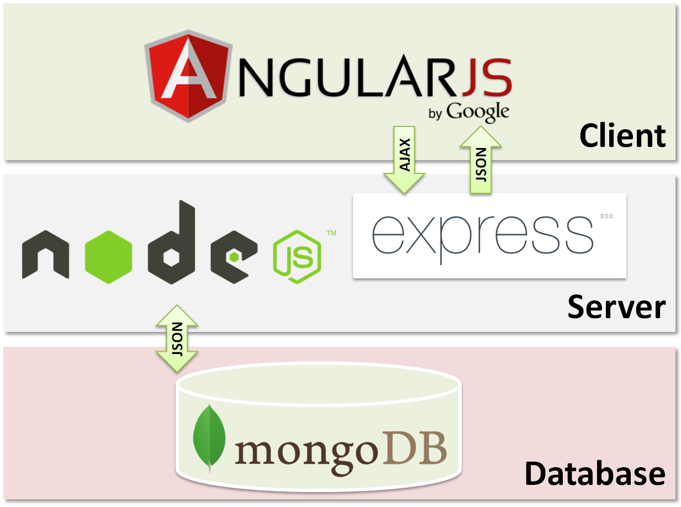

The frontend(client) is composed of Angular 2. The diagram below shows what Angular 2 is composed of.

* Application namespace: This is declared to group all the components needed for the application which translates to JavaScript object.
* Bootstrap: A powerful front-end framework that allows the application to behave faster and easier to develop.
* Components: Our web page was created using component per section.
  + Main components: This component is the one that is first called and bootstrapped at the beginning of the application and in charge of calling all other components and making it look like a unity.
  + Secondary components: Are the components that will be display to the user as the user navigates the application. They are directly associated with the view and CSS file.
* Routes: are mapping between the component and the different URLs used on the website.
* Services: Services are JavaScript functions and specific tasks that are used in the components.

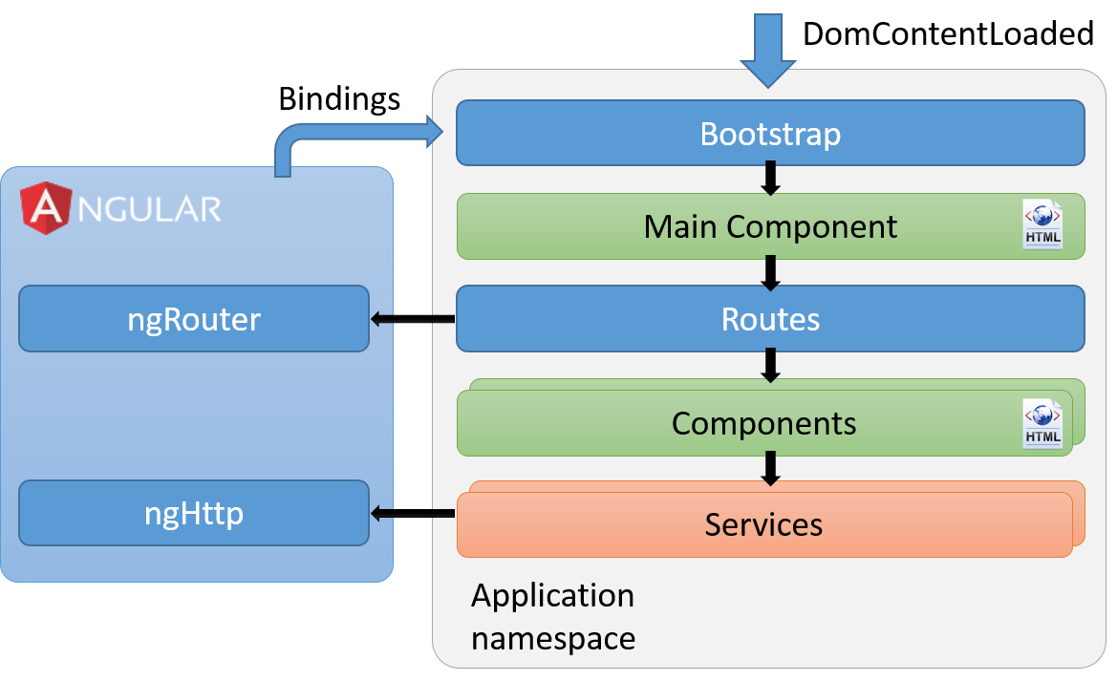

The backend(server) is composed of Node js, Express js and the database(MongoDB). The diagram below shows what how Node.js and MongoDB work together.

* Node.js: Is the execution environment on the server side.
  + Express: Is a web framework that runs on Node.js
  + Mongoose: Is used to provide connection to the database
* MongoDB: a NoSQL database

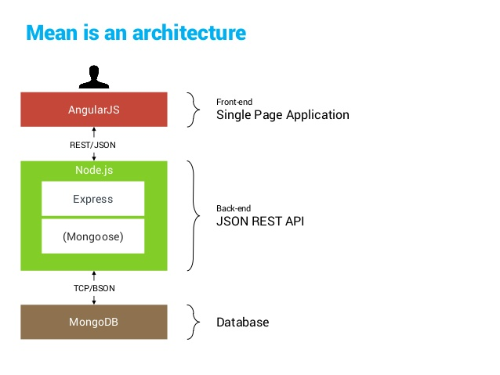

## Deployment Diagram

If the webpage were to be deploy, the deployment diagram will look like the one below.

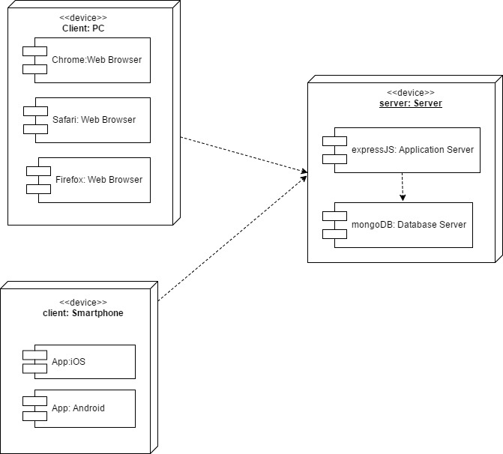

## Design Patterns

We used following design pattern to develop our system:

**Singleton**

In the backend of our application there are several routes that render when certain tabs are clicked by the user. Figure 4.4.1 shows the routing of the product page in the backend. We have created routes for each of our menu items in the navbar. We have separate files for each of the routes such as routing for home page, technology page, about us page, contact us page, blog page, and subscription page.

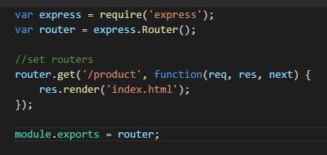

Figure 4.4.1 router for product page

Figure 4.4.2 show the server.js class that requires those routes described above. It doesn’t matter how many times you will require these modules in this application, these will only exist as single instance.

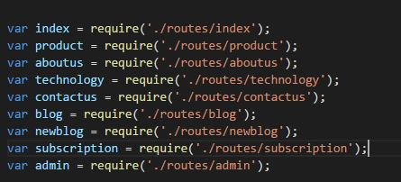

Figure 4.4.2 Part of Server.js class

**Component design pattern**

We have different folder as component for each section of our homepage. Figure 4.4.3 shows the structure of the folders we have used in our project. Each component contains only elements with related functionality. This helps us to manage the different section of the webpage more easily. Also with this structure our code is easy to maintain and easier to read.

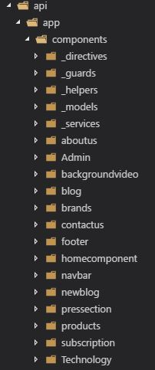

Figure 4.4.3 Directory structure

**Dependency Injection pattern**

We have injected several dependencies into the angular components through data model and services. For example, as figure 4.4.4 shows BlogService has been injected into class Blog through constructor injection. We have also injected services to admin login class, subscription

Class, and contact us class.

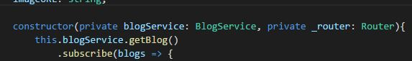

Figure 4.4.4 Service injection to blog class

# 

# System Validation

**User Story #120 Set Up the Localhost Server**

**Test case 1(Sunny Day)**

* Test case ID: DCW-120-01
* Description/Summary of Test: Ensure that the server is working properly.
* Precondition: The server is running on the localhost port 3000.
* Expected Results: Developer can access the localhost on port 3000 successfully.
* Actual Result: Developer could access the localhost successfully.
* Status (Fail/Pass): PASSED

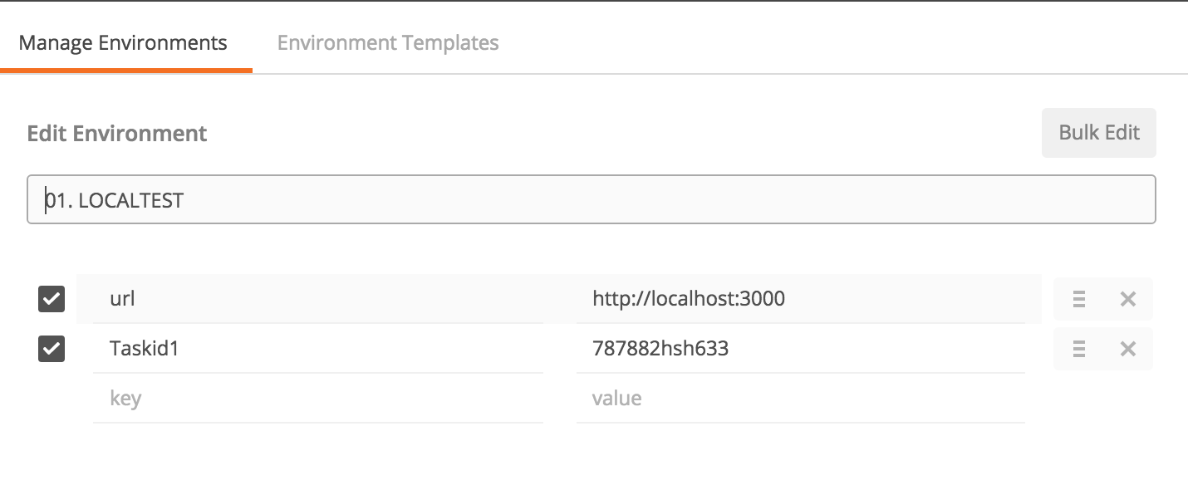

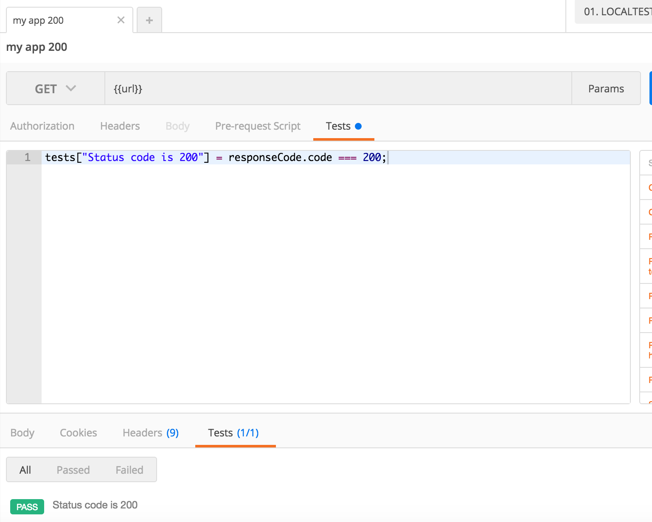

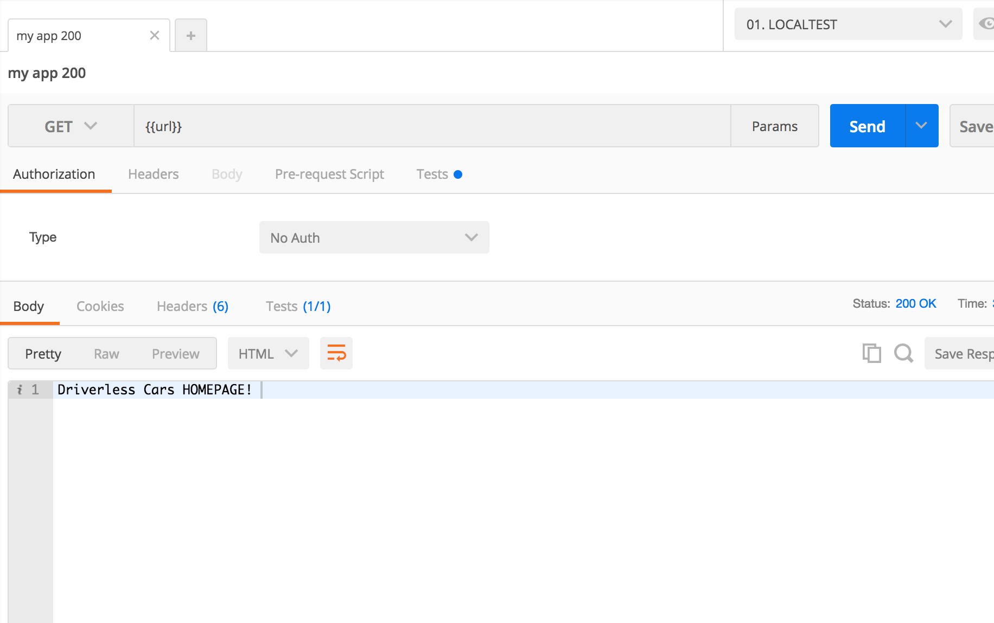

**Test case 2(Rainy Day)**

* Test case ID: DCW-120-02
* Description/Summary of Test: Ensure that the server is working properly.
* Precondition: The server is running on the localhost port 3000, but developer input port 8000.
* Expected Results: Developer is unable to access the localhost on port 3000 successfully.
* Actual Result: Developer was not able to access the localhost successfully due to incorrect port number.
* Status (Fail/Pass): FAILED

**User Story #117 Create a homepage with high-tech look**

**Test Case 1 (Sunny Day)**

* **Test case ID:** Homepage_001
* **Description/Summary of Test:** To test that header of the homepage is displaying with correct tabs.
* **Precondition:** Server is up and running.
* **Input:** User opens the browser and enters http://localhost:3000
* **Expected Results:** Web page is displayed with homepage showing header and the tabs.
* **Actual Result:** Web page is displayed with homepage showing header and the tabs.
* **Status (Fail/Pass)**: PASS

**Test Case 2 (Sunny Day)**

* **Test case ID:** Homepage_002
* **Description/Summary of Test:** To test that homepage can be viewed in different browser
* **Precondition:** Server is up and running.
* **Input:**

1. User opens google chrome browser and enters <http://localhost:3000>.
2. User opens Mozilla Firefox browser and enters <http://localhost:3000>.
3. User opens Safari browser and enters http://localhost:3000.

* **Expected Results:** Web page is launched with homepage in each browser
* **Actual Result:** Web page is launched with homepage in each browser
* **Status (Fail/Pass)**: PASS

**Test Case 3(Rainy Day)**

* **Test case ID:** Homepage_002
* **Description/Summary of Test:** To test that the homepage won’t display if the user enters incorrect web address.
* **Precondition:** Server is up and running.
* **Input:** User opens the browser and enters [http://localhost](http://localhost:3000).
* **Expected Results:** Web page is not displayed with homepage.
* **Actual Result:** Web page is not displayed with homepage.
* **Status (Fail/Pass)**: PASS

**User Story #119 Create Routes**

**Test case 1(Sunny Day)**

* Test case ID: DCW-119-01
* Description/Summary of Test: Ensure that each route is working properly.
* Precondition: The server is running on the localhost port 3000.
* Expected Results: Developer can access successfully:
* [http://localhost:3000](http://localhost:3000/)/contactus
* [http://localhost:3000](http://localhost:3000/)/aboutus
* [http://localhost:3000](http://localhost:3000/)/mission
* [http://localhost:3000](http://localhost:3000/)/technology
* [http://localhost:3000](http://localhost:3000/)/team
* [http://localhost:3000](http://localhost:3000/)/product
* Actual Result: Developer could access routes successfully.
* Status (Fail/Pass): PASSED

**Test case 2(Rainy Day)**

* Test case ID: DCW-119-02
* Description/Summary of Test: Ensure that the routes are working properly.
* Precondition: The server is running on the localhost port 3000, but developer input:
* [http://localhost:3000](http://localhost:3000/)/contact
* [http://localhost:3000](http://localhost:3000/)/about
* [http://localhost:3000](http://localhost:3000/)/missio
* [http://localhost:3000](http://localhost:3000/)/technolo
* [http://localhost:3000](http://localhost:3000/)/tea
* [http://localhost:3000](http://localhost:3000/)/products
* Expected Results: Developer is unable to access the routes successfully.
* Actual Result: Developer was not able to access the routes successfully due to incorrect link.
* Status (Fail/Pass): PASSED

**User Story ID #197 Blog Page**

**Test case 1(Sunny Day)**

* Test case ID: DCW-197-01
* Description/Summary of Test: Ensure that the blog page route is working properly.
* Precondition: The server is running on the localhost port 3000.
* Expected Results: Visitor can access blog page successfully
* Actual Result: Visitor could access blog page successfully.
* Status (Fail/Pass): PASSED

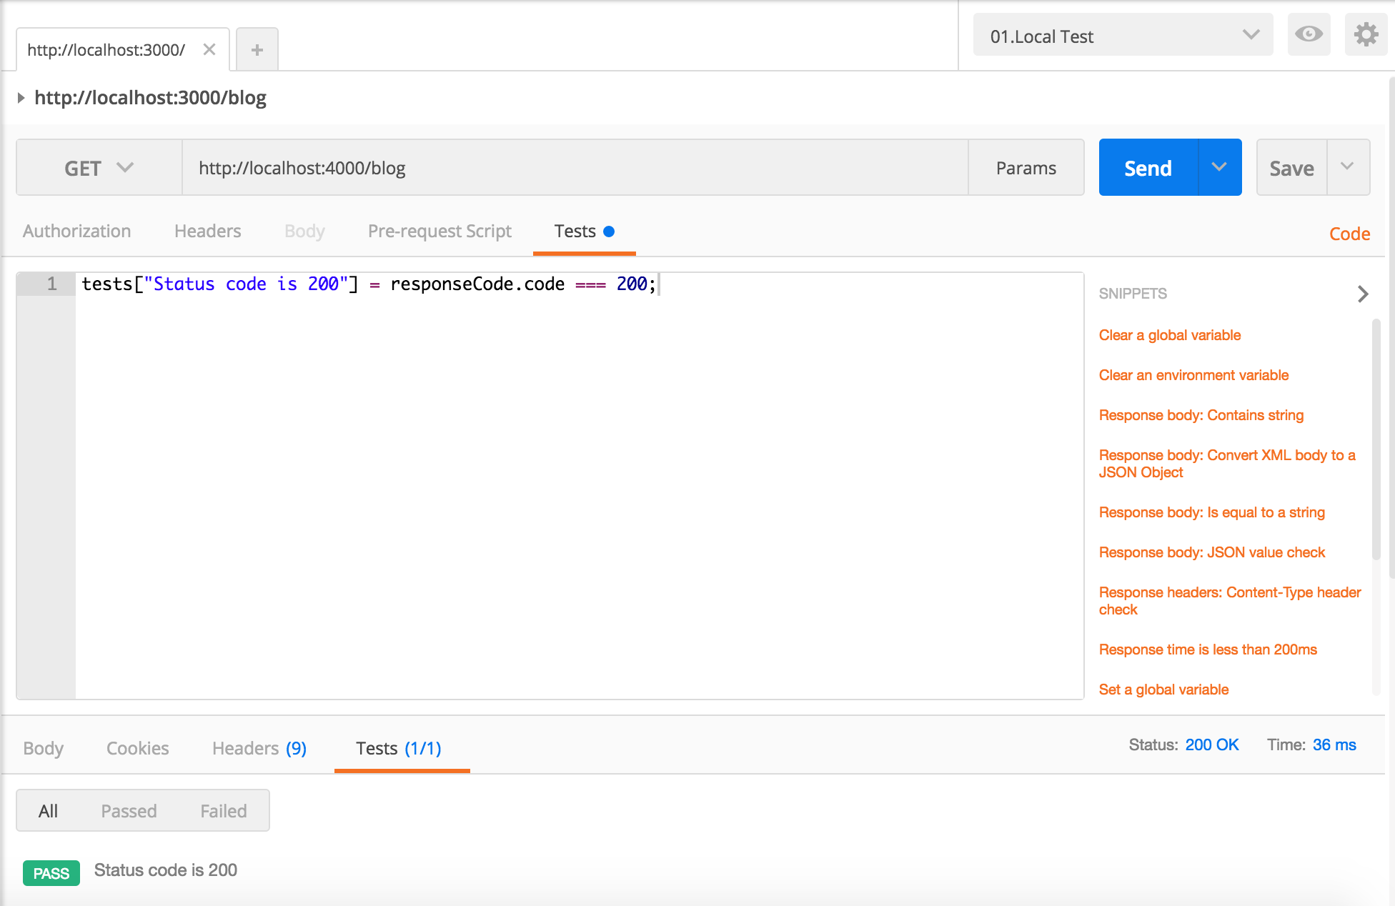

**Test case 2(Rainy Day)**

* Test case ID: DCW-197-02
* Description/Summary of Test: Ensure that the blog page route is working properly
* Precondition: The server is running on the localhost port 3000, but visitor lost internet access.
* Expected Results: Visitor is unable to access the blog page successfully.
* Actual Result: Visitor was not able to access the blog page successfully due to problem with connection.
* Status (Fail/Pass): PASSED

**User Story ID #176 Create routes and components using angularJs**

**Test case 1(Sunny Day)**

* Test case ID: Contactus_001
* Description/Summary of Test: Ensure the contact us tab navigate to the contact us form.
* Precondition:1. The server is running on the localhost port 3000.

2.User click contact us tab.

* Expected Results: User is redirected to the contact us form
* Actual Result: User is redirected to the contact us form
* Status (Fail/Pass): PASSED

**Test case 2(Sunny Day)**

* Test case ID: Tabs_002
* Description/Summary of Test: To test if the user can navigate back to the home page after visiting the different tab.
* Precondition:1. The server is running on the localhost port 3000.

2.User click product tab or technology tab or contact us tab or about us tab.

3. User click home tab

* Expected Results: User is redirected to the home page
* Actual Result: User is redirected to the home page
* Status (Fail/Pass): PASSED

**Test case 1(Rainy Day)**

* Test case ID: Contactus_001
* Description/Summary of Test: To test that the contact us tab won’t navigate to the contact us form if the internet connection is lost.
* Precondition:1. The server is running on the localhost port 3000.

2.User click contact us tab.

* Expected Results: User won’t be redirected to the contact us form
* Actual Result: User won’t be redirected to the contact us form
* Status (Fail/Pass): PASSED

**User Story #208 Add blog post**

**Test case 1(Sunny Day)**

* Test case ID: DCW-208-01
* Description/Summary of Test: Ensure that the articles are being posted successfully.
* Pre-condition:

1. The server is running on the localhost port 4000
2. Admin click blog menu tab.
3. Admin click add new post button
4. Admin enters:
   1. Username: admin
   2. Password: 1234
5. Admin enters:
   1. Title
   2. Content
   3. Image

* Expected Results: Admin can post an article to the database and the blog page successfully
* Actual Result: Admin could post articles to the blog page successfully.
* Status (Fail/Pass): PASSED

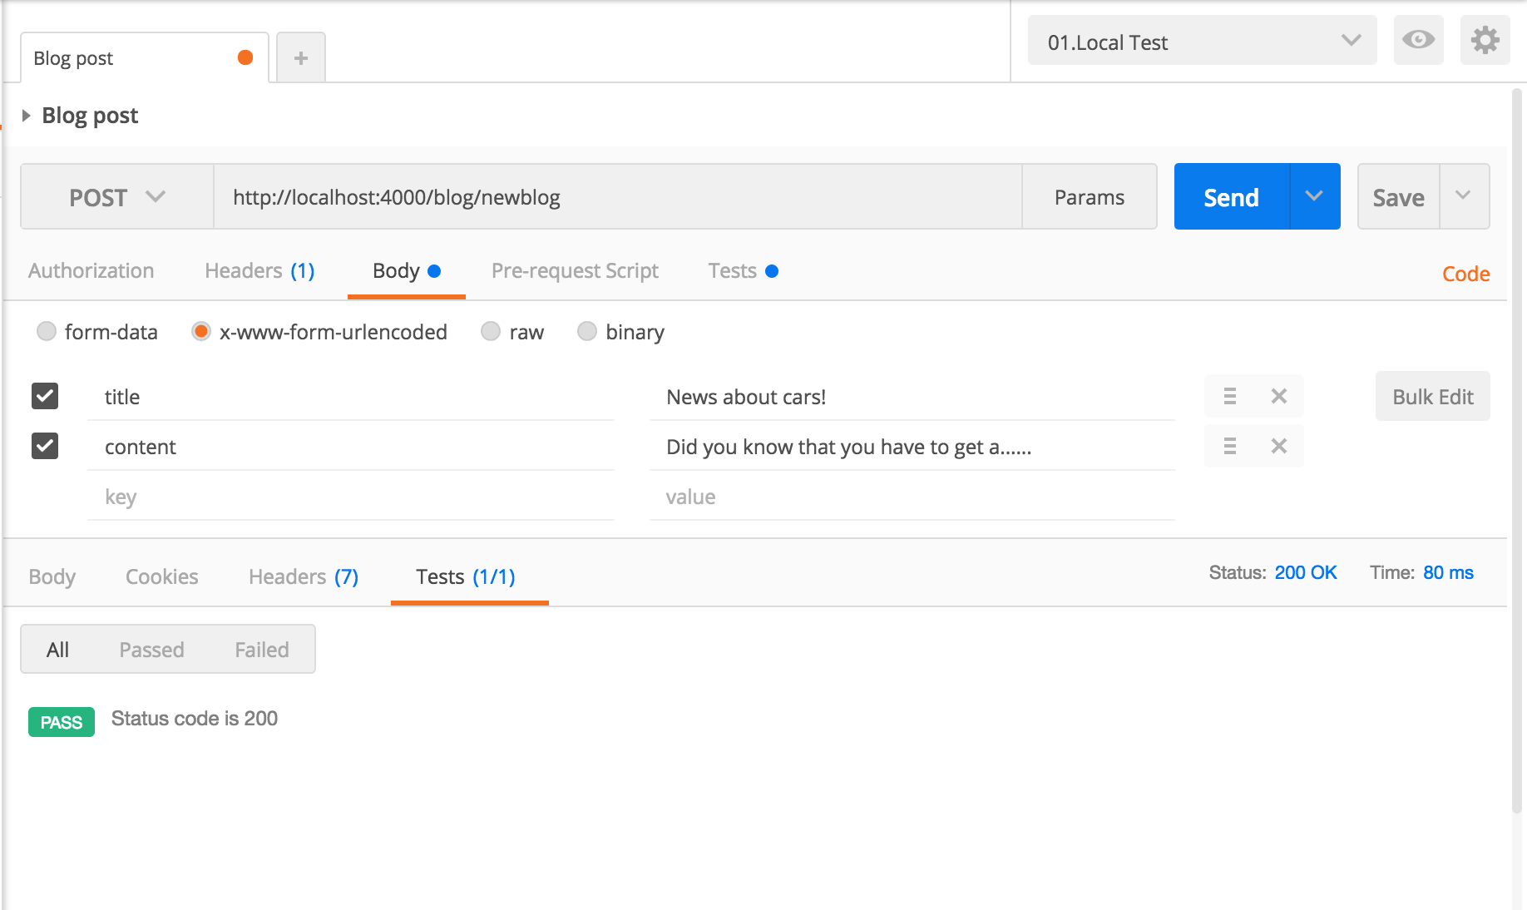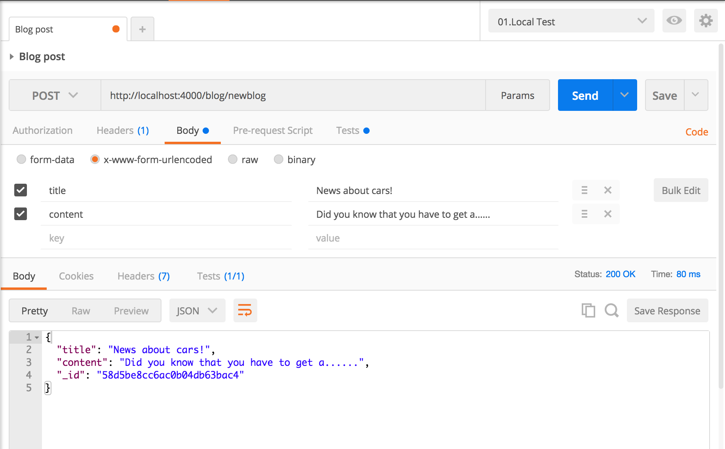

**Test case 2(Rainy Day)**

* Test case ID: DCW-208-02
* Description/Summary of Test: Admin leaves a field empty
* Precondition: The server is running on the localhost port 4000

1. Admin click blog menu tab.
2. Admin click add new post button
3. Admin enters:
   1. Username: admin
   2. Password: 1234
4. Admin enters:
   1. Title
   2. Image

* Expected Results: Visitor is unable to post an article to the blog page and database successfully.
* Actual Result: Admin was not able to successfully post an article to the blog page and the database.
* Status (Fail/Pass): PASSED

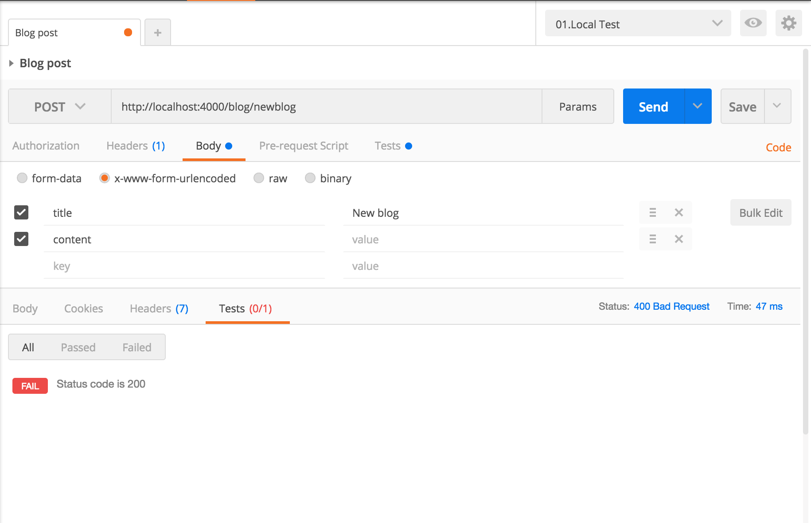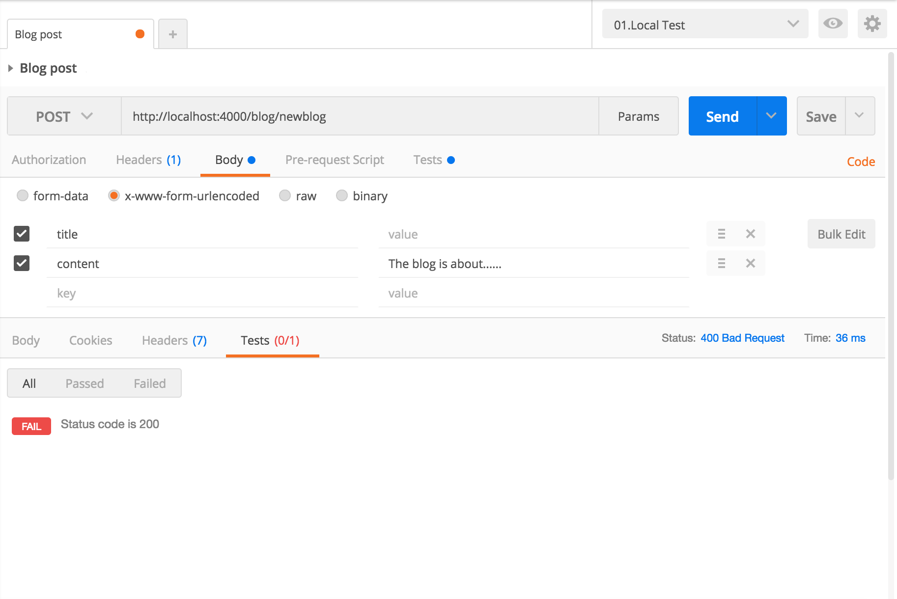

**User Story #122 Set up an admin login page**

**Test case 1(Sunny Day)**

* Test case ID: Login_001
* Description/Summary of Test: To test if admin can login with correct credentials.
* Precondition:1. The server is running on the localhost port 4000.

2.Admin click blog menu tab.

3. Admin click add post button

4.Admin enters:

Username: admin

Password: 1234

* Expected Results: Admin gets logged in and redirect to the add post form.
* Actual Result: Admin gets logged in and redirect to the add post form.
* Status (Fail/Pass): PASSED

**Test case 2(Rainy Day)**

* Test case ID: Login_002
* Description/Summary of Test: To test if admin can’t login with incorrect credentials.
* Precondition:1. The server is running on the localhost port 4000.

2.Admin click blog menu tab.

3. Admin click add post button

4.Admin enters:

Username: admin

Password: kkkk

* Expected Results: Admin won’t redirect to the add blog post form.
* Actual Result: Admin won’t redirect to the add blog post form.
* Status (Fail/Pass): PASSED

**User Story ID #216 Implementing contact us form**

**Test case 1(Sunny Day)**

* Test case ID: Contactus_001
* Description/Summary of Test: To test the contact form submitted successfully after the user enters the information.
* Precondition:1. The server is running on the localhost port 4000.

2.User clicks contact us tabs from the navbar

3.User enters:

Name: Test

Email: test@gmail.com

Subject: Hai

Message: Getting some info

4. User clicks submit button

* Expected Results: Message is sent to the driverlesscarinfo@gmail.com
* Actual Result: Message is sent to the driverlesscarinfo@gmail.com
* Status (Fail/Pass): PASSED

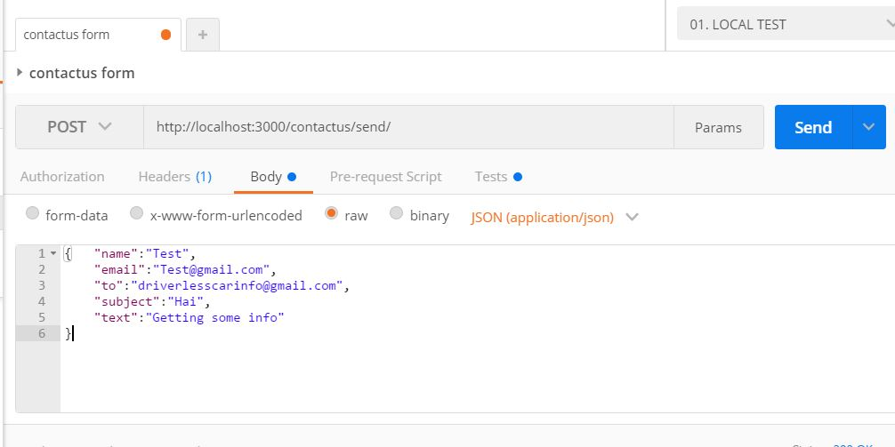

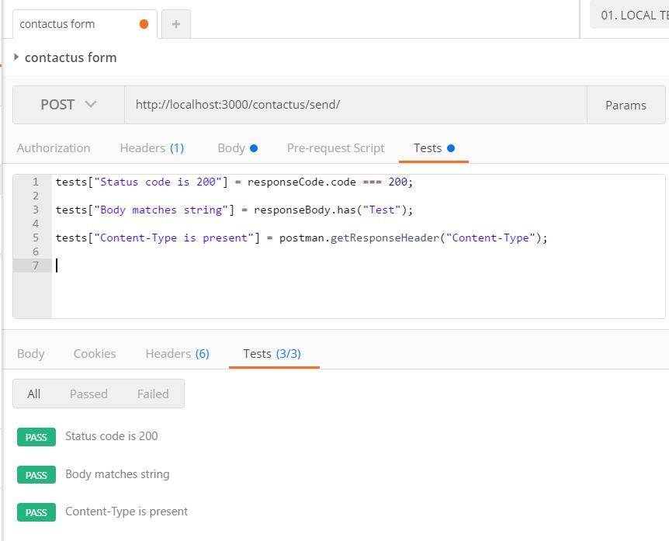

**Test case 2(Rainy Day)**

* Test case ID: Contactus_002
* Description/Summary of Test: To test the contact form won’t be submitted successfully if the user leave the name field empty
* Precondition:1. The server is running on the localhost port 4000.

2.User clicks contact us tabs from the navbar

3.User enters:

Name:

Email: [alicewalter@gmail.com](mailto:alicewalter@gmail.com)

Subject: New Mail

Message: New message to driverless car

4. User clicks submit button

* Expected Results: Message won’t sent to the [driverlesscarinfo@gmail.com](mailto:driverlesscarinfo@gmail.com) and name is required message will show.
* Actual Result: Message won’t sent to the [driverlesscarinfo@gmail.com](mailto:driverlesscarinfo@gmail.com) and name is required message will show.
* Status (Fail/Pass): FAILED

**User Story #215 Implementing subscription form**

**Test case 1(Sunny Day)**

* Test case ID: DCW-215-01
* Description/Summary of Test: Ensure that the subscriber information is being stored to the database properly.
* Pre-condition:

1. The server is running on the localhost port 4000
2. Visitor is in the homepage.
3. Visitor scrolls down to footer
4. Visitor enters:
   1. name
   2. email
5. Visitor clicks subscribe button

* Expected Results: Subscription form is sent correctly
* Actual Result: Subscription form was sent successfully.
* Status (Fail/Pass): PASSED

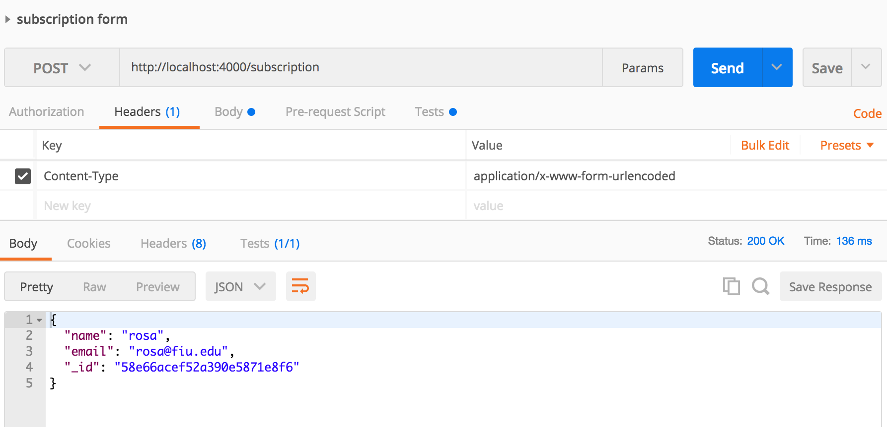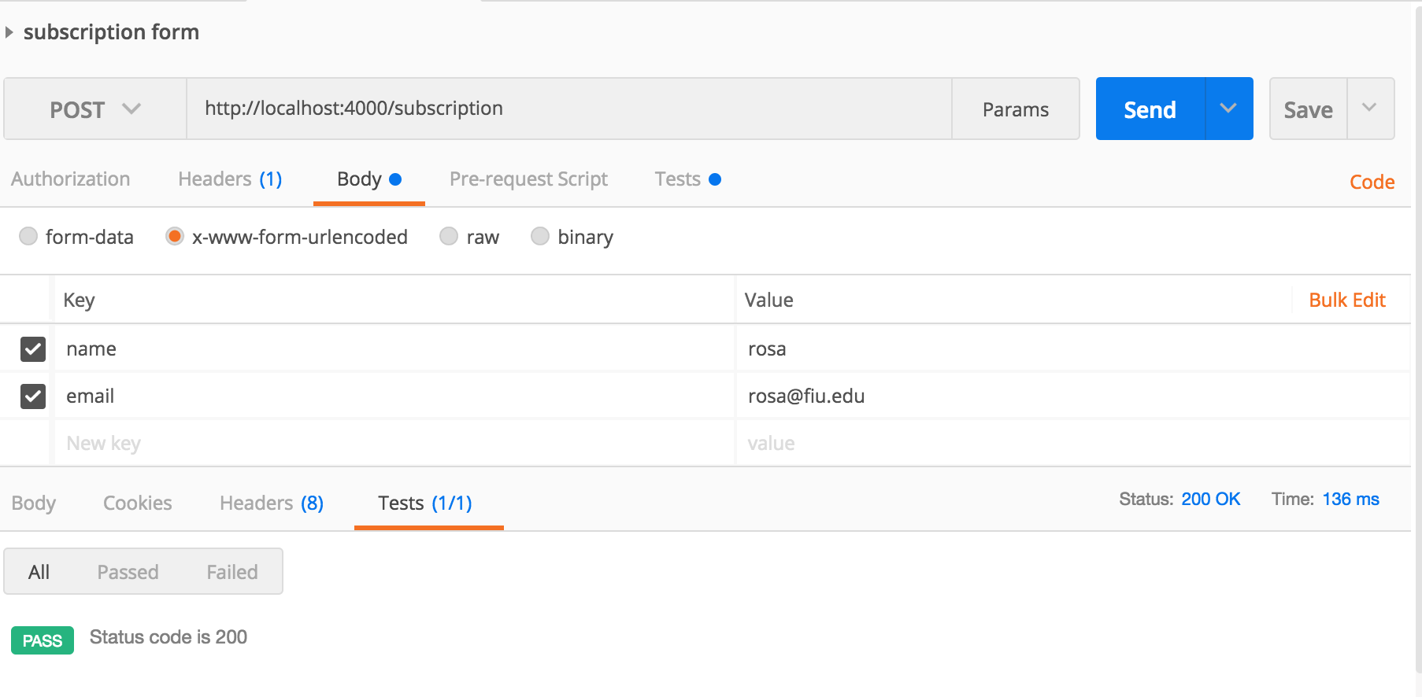

**Test case 2(Rainy Day)**

* Test case ID: DCW-215-02
* Description/Summary of Test: Visitor leaves a field empty
* Pre-condition:

1. The server is running on the localhost port 4000
2. Visitor is in the homepage.
3. Visitor scrolls down to footer
4. Visitor enters:
   1. name
5. Visitor clicks subscribe button

* Expected Results: Subscription form is not sent correctly since there email was not enter.
* Actual Result: Visitor was not able to subscribe correctly
* Status (Fail/Pass): PASSED

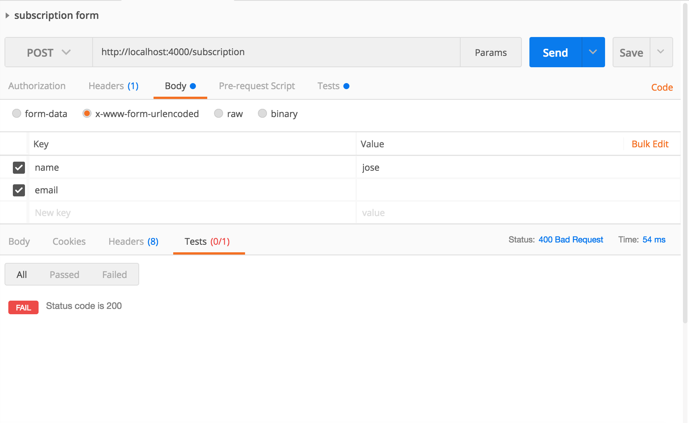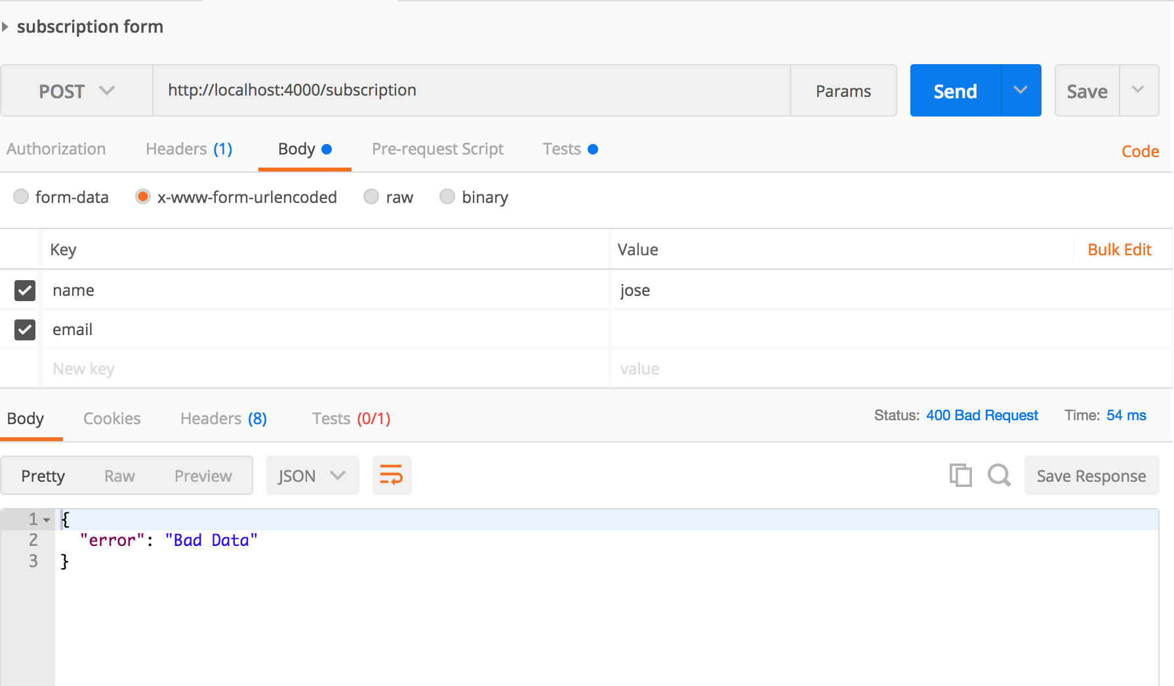

# 

# 

# Glossary

**Minimum viable product (MVP):** is a product with just enough features to satisfy early customers, and to provide feedback for future development

**Demo:** provides information about the product

**User story:** A tool used in agile software development to capture a description of a software feature from an end user perspective.

**Implementation:** the interactions of elements in programming languages.

**Sprint:** is the basic unit of development in scrum. It is restricted to a specific duration.

**MEAN stack:**  is a free and open-source JavaScript software stack for building dynamic web sites and web applications. The MEAN stack is MongoDB, ExpressJS, AnguarJS, and NodeJS.

# Appendix

## Appendix A - UML Diagrams

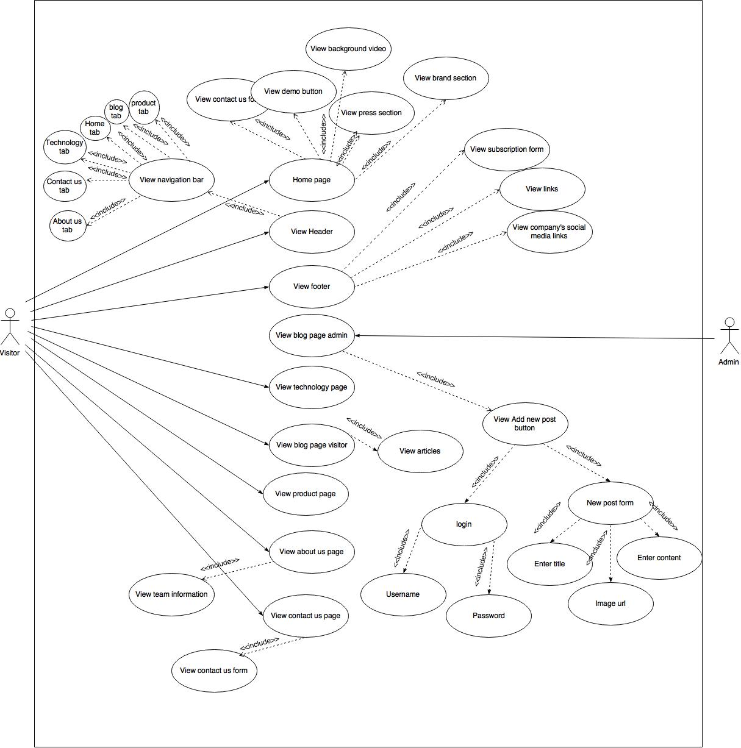

Class Diagram

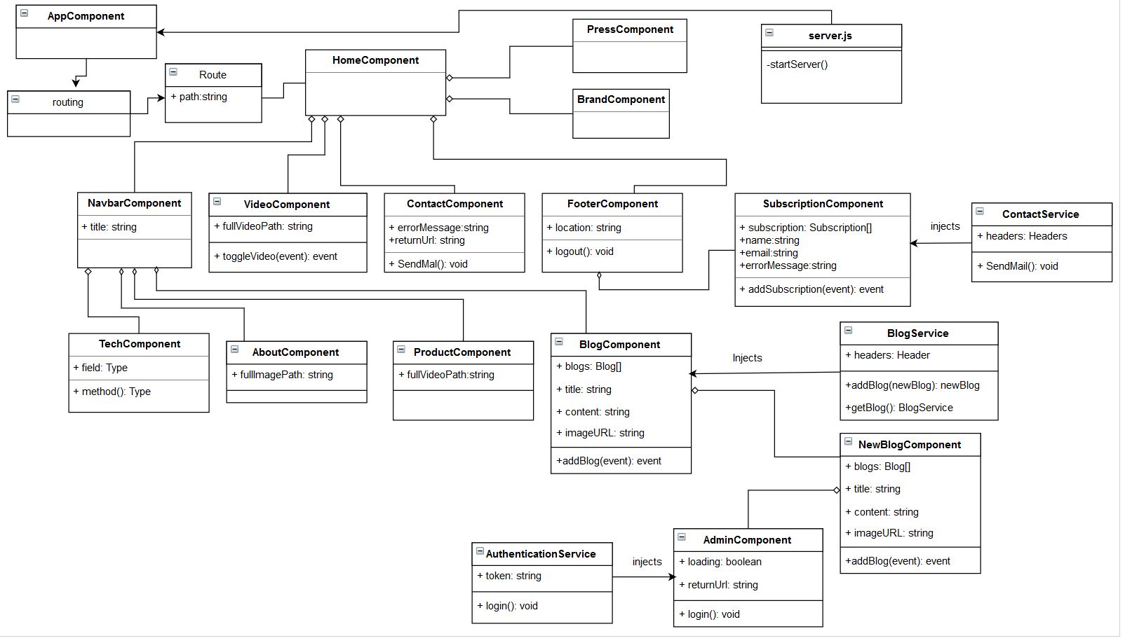

**User Story #120 Set Up the Localhost Server**

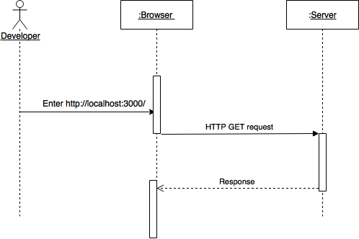

**User Story #117 Create a homepage with high-tech look**

Untitled Diagram.png

**User Story #119 Create Routes**

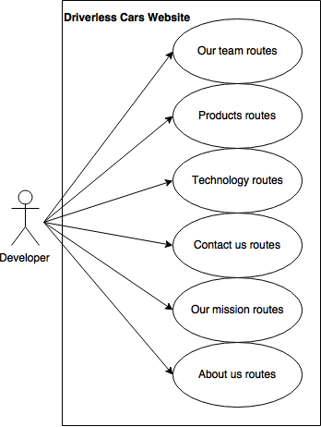

**User Story ID #197 Blog Page**

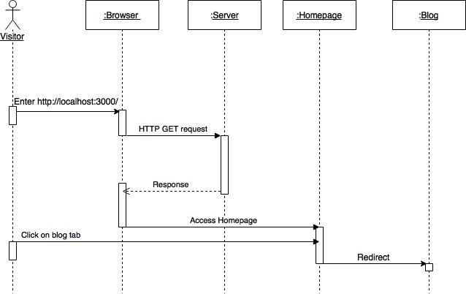

**User Story ID #176 Create routes and components using angularJs**

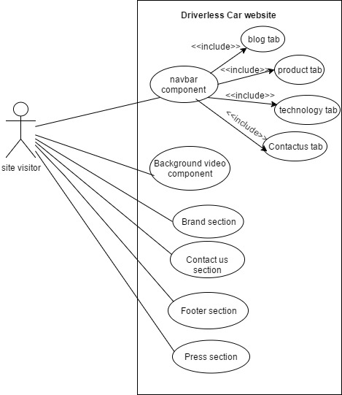

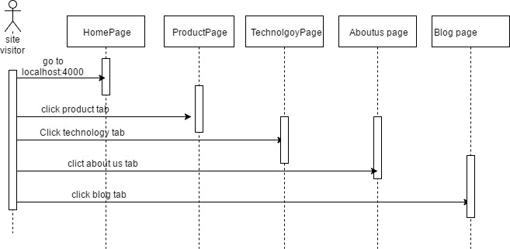

Minimal class diagram for the user story #176

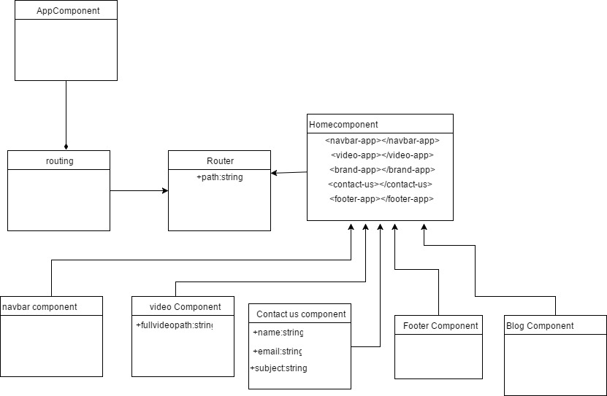

**User Story #208 Add blog post**

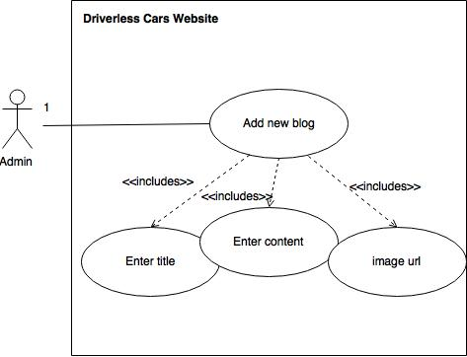

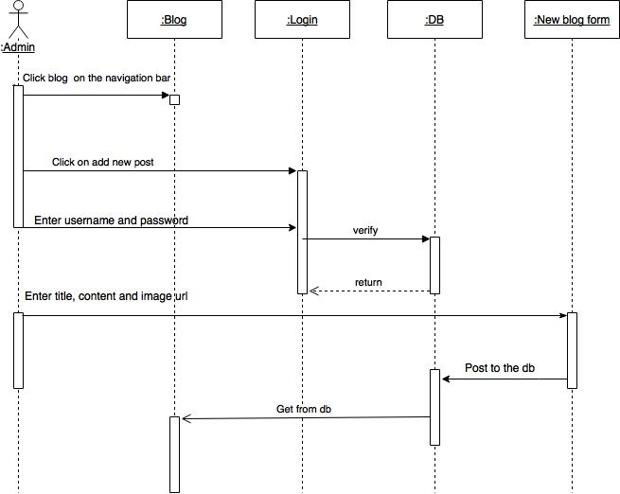

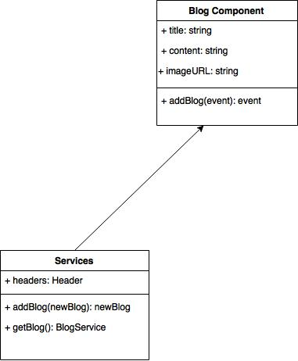

**User Story #122 Set up an admin login page**

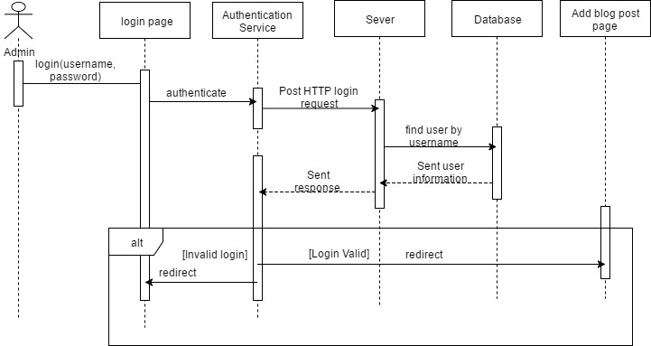

**User Story ID #216 Implementing contact us form**

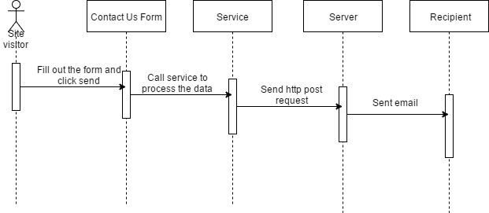

**User Story #215 Implementing subscription form**

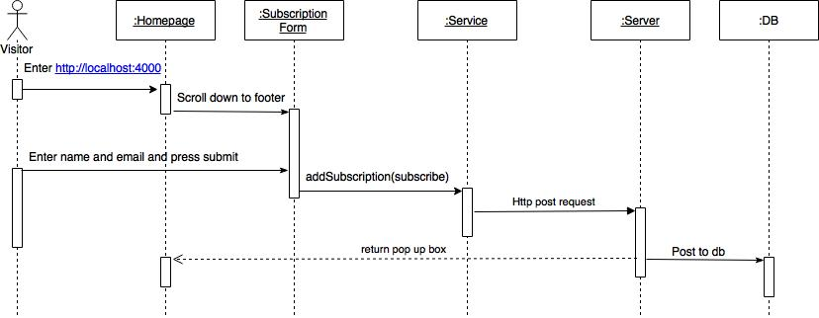

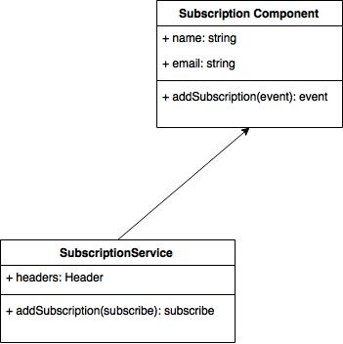

## 

## Appendix B - User Interface Design

Figure #1 Homepage with background video

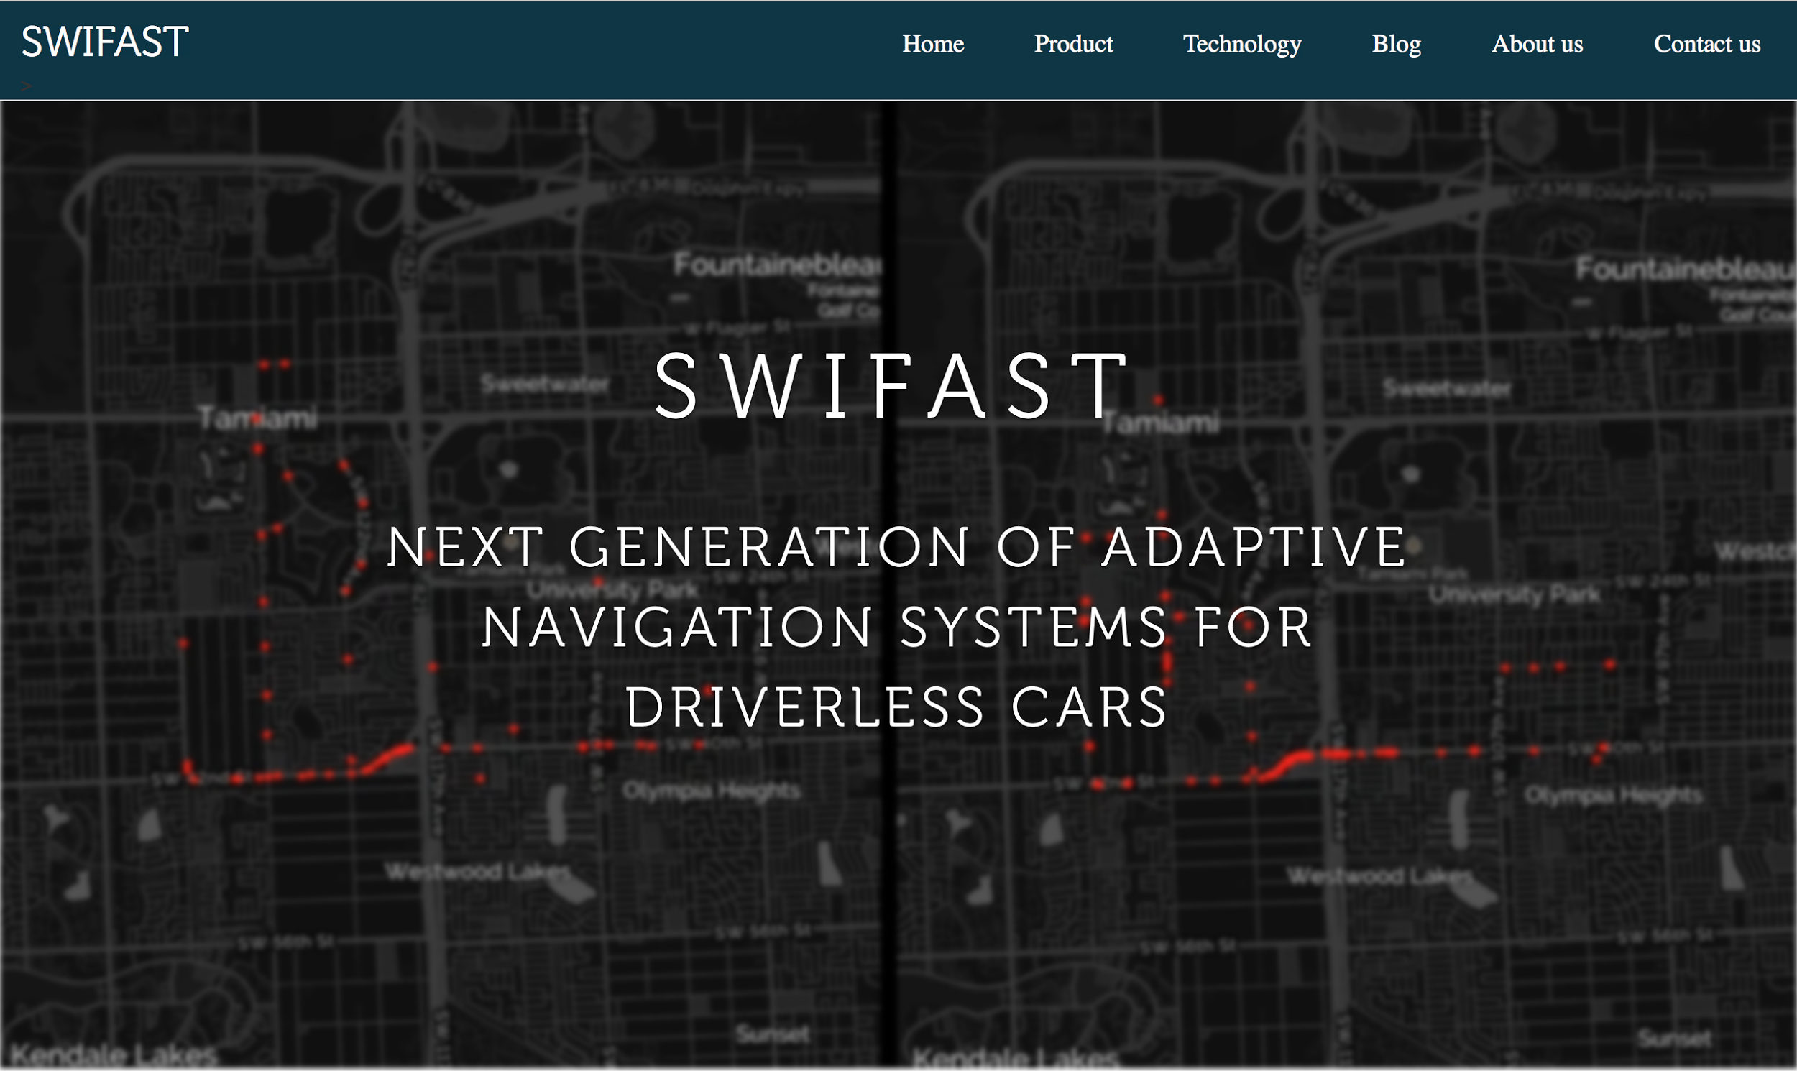

Figure #2 Brand section

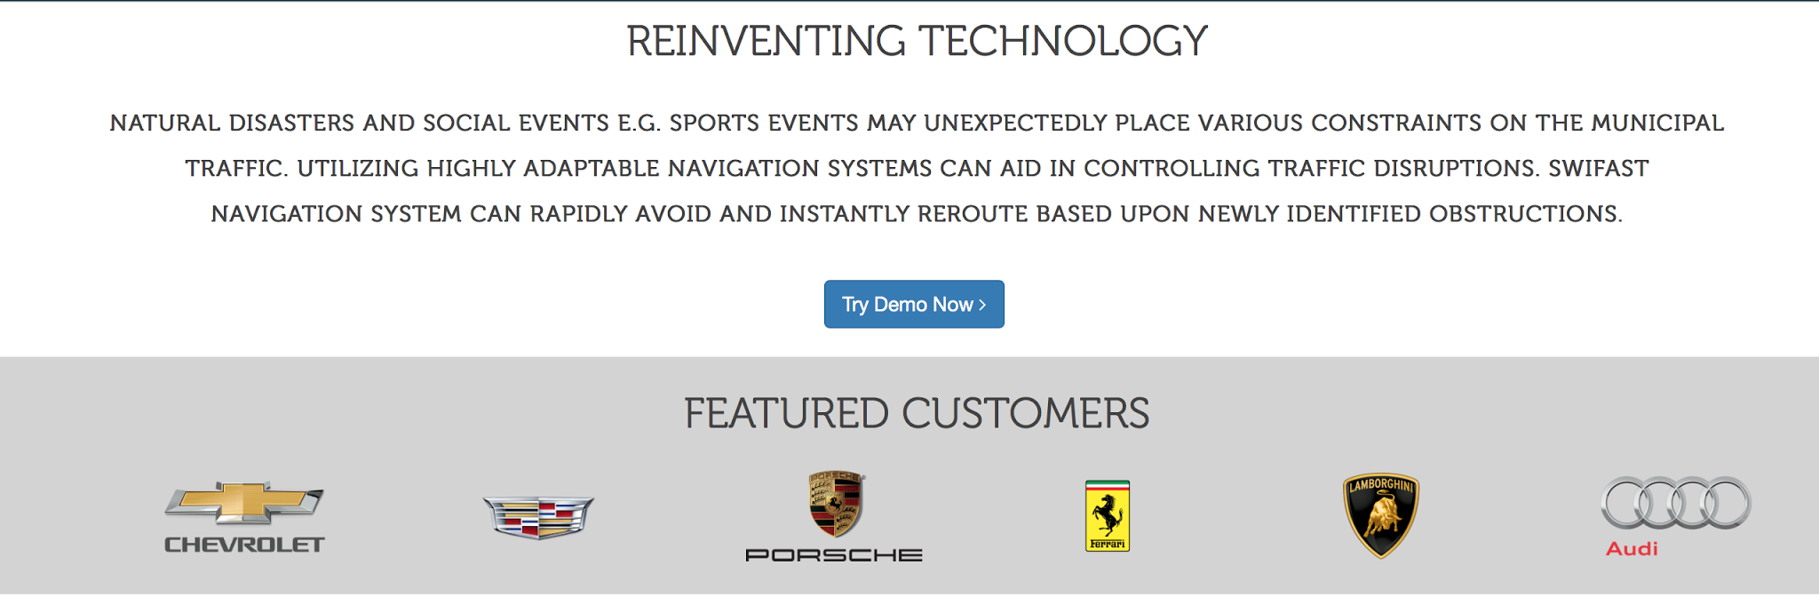

Figure#3Contact us and press section

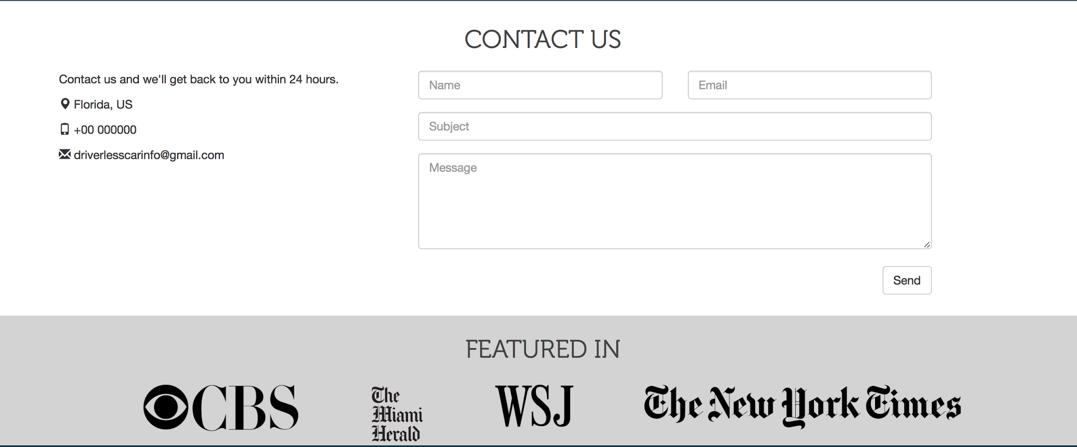

Figure #4-Footer with subscription form

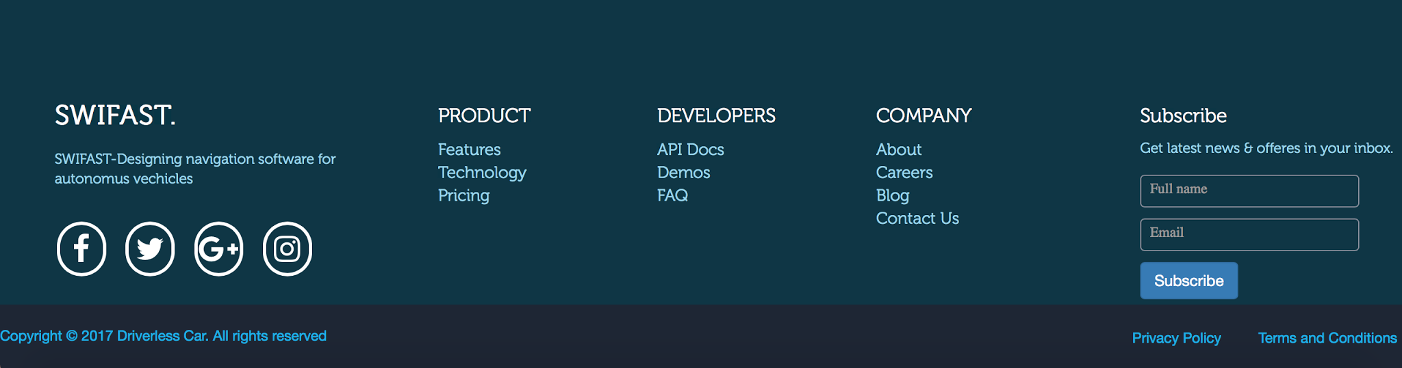

Figure#5 New blog post form

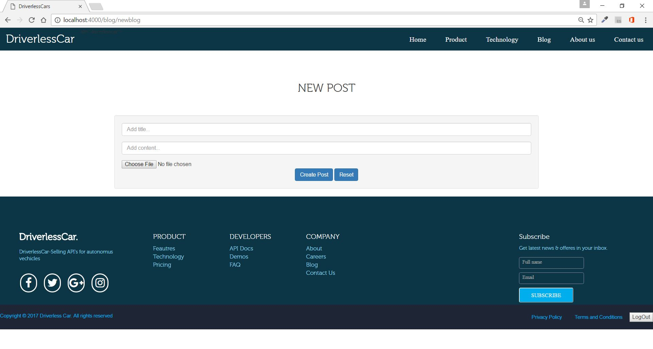

Figure#6 Admin Login page

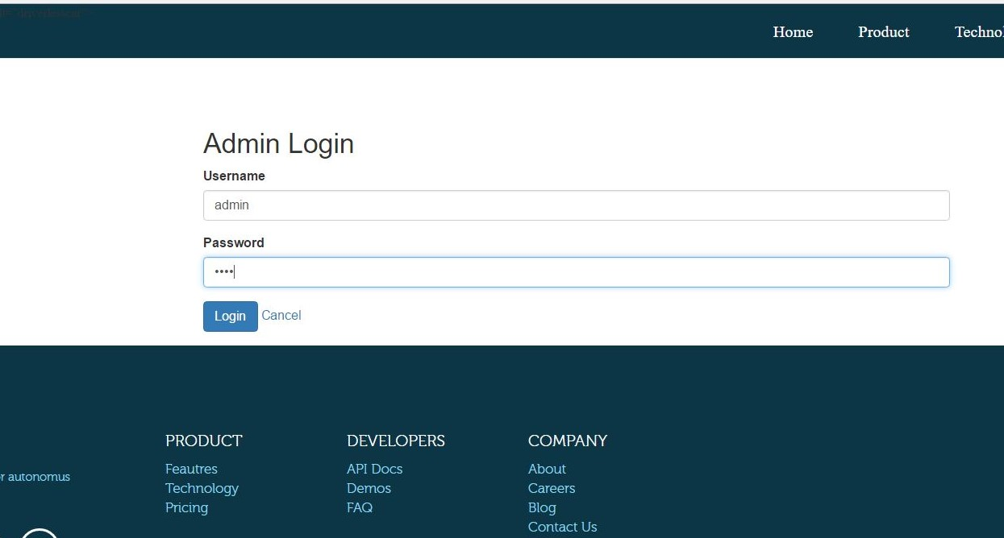

Figure#7 Technology page

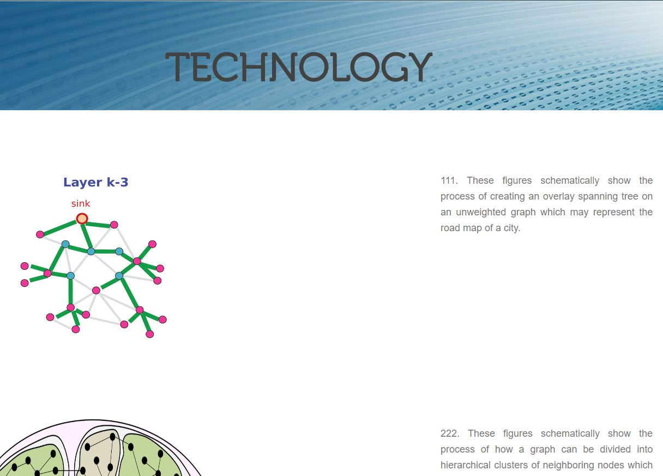

Figure#8 Download our api button

## product.JPG

## 

## 

## 

## Appendix C - Sprint Review Reports

**Daily Scrum Meeting Minutes: 2/2/2017**

Attendees: Mariana Sebastian, Nathally Perez

Start time: 2:00PM

End time: 3:00 PM

Mariana Sebastian:

* What was done since the last scrum meeting?
* I start working on the homepage. I learned about bootstrap.
* What is planned to be done until the next scrum meeting?
* Do more work on the home page. Start learning angular.
* What are the hurdles?
* Placing homepage video on the website

<Nathally Perez>:

* What was done since the last scrum meeting?
* Set up the server. I also was working on learning more information about the frontend and backend.
* What is planned to be done until the next scrum meeting?
* Testing the server, working on the demo bottom and the footer.
* What are the hurdles?
* Setting up the server

**Daily Scrum Meeting Minutes: 2/3/2017**

Attendees: Mariana Sebastian, Nathally Perez

Start time: 6:00 PM

End time: 7:00 PM

Mariana Sebastian:

* What was done since the last scrum meeting?
* Fixed some code for the home page, and learned how to use the GitHub
* What is planned to be done until the next scrum meeting?
* Start doing the documentation, and continue work on the user story for the sprint 1.
* What are the hurdles?
* NA

<Nathally Perez>:

* What was done since the last scrum meeting?
* Created demo button and work on setting up GitHub and some documentations
* What is planned to be done until the next scrum meeting?
* Continue the documentation and better the homepage
* What are the hurdles?
* I am new to front-end development, so it took me a while before I could start developing

**Daily Scrum Meeting Minutes: 2/6/2017**

Attendees: Mariana Sebastian, Nathally Perez

Start time: 8:00 PM

End time: 9:00 PM

Mariana Sebastian:

* What was done since the last scrum meeting?
* Start working on the document
* What is planned to be done until the next scrum meeting?
* Create uml diagrams, sequence diagrams, and class diagrams for the user story.
* What are the hurdles?
* Drawing the sequence, and class diagram

<Nathally Perez>:

* What was done since the last scrum meeting?
* I worked on making some changes to the header, adding some additional details to the homepage
* What is planned to be done until the next scrum meeting?
* Continue working on the documentation
* What are the hurdles?
* N/A

**Daily Scrum Meeting Minutes: 2/7/2017**

Attendees: Mariana Sebastian, Nathally Perez

Start time: 3:00 PM

End time: 4:00 PM

Mariana Sebastian:

* What was done since the last scrum meeting?
* Completed use case diagram, and sequence diagram
* What is planned to be done until the next scrum meeting?
* Start testing the user story
* What are the hurdles?
* Learning the testing tool

<Nathally Perez>:

* What was done since the last scrum meeting?
* Use case diagram and some extra information on documents
* What is planned to be done until the next scrum meeting?
* Continue working on the documentation including sequence diagram
* What are the hurdles?
* N/A

**Daily Scrum Meeting Minutes: 2/8/2017**

Attendees: Mariana Sebastian, Nathally Perez

Start time: 11:00 PM

End time: 12:00 PM

Mariana Sebastian:

* What was done since the last scrum meeting?
* Did some testing, fixed the homepage
* What is planned to be done until the next scrum meeting?
* Finish with testing, add more to the homepage
* What are the hurdles?
* Learning the testing tool

<Nathally Perez>:

* What was done since the last scrum meeting?
* User story document and testing
* What is planned to be done until the next scrum meeting?
* Make some changes to the Homepage
* What are the hurdles?
* Learning testing tools

**Daily Scrum Meeting Minutes: 2/9/2017**

Attendees: Mariana Sebastian, Nathally Perez

Start time: 6:00 PM

End time: 7:00 PM

Mariana Sebastian:

* What was done since the last scrum meeting?
* Added test cases to the document. Did some fixes on the homepage of the website
* What is planned to be done until the next scrum meeting?
* Finish up with document
* What are the hurdles?
* Fixing the conflict in GitHub

<Nathally Perez>:

* What was done since the last scrum meeting?
* Finish homepage
* What is planned to be done until the next scrum meeting?
* Start planning for next sprint
* What are the hurdles?
* N/A

**Daily Scrum Meeting Minutes: 2/10/2017**

Attendees: Mariana Sebastian, Nathally Perez

Start time: 11:00 AM

End time: 1:00 PM

Mariana Sebastian:

* What was done since the last scrum meeting?
* Finished sprint 1 user stories and
* What is planned to be done until the next scrum meeting?
* Start working on Sprint 2
* What are the hurdles?
* Resolving the conflict in GitHub

<Nathally Perez>:

* What was done since the last scrum meeting?
* Finish sprint 1 user stories and we did our spring meeting
* What is planned to be done until the next scrum meeting?
* Start Sprint 2
* What are the hurdles?
* Conflict with committing in GitHub and overall learning how to create a homepage from scratch.

**Daily Scrum Meeting Minutes: 2/13/2017**

Attendees: Mariana Sebastian, Nathally Perez

Start time: 7:00 PM

End time: 8:00 PM

Mariana Sebastian:

* What was done since the last scrum meeting?
* Added user story for the sprint 2 in Mingle, learned some angularJS
* What is planned to be done until the next scrum meeting?
* Start working on the user story for the spring 2
* What are the hurdles?
* Learning the typescript

<Nathally Perez>:

* What was done since the last scrum meeting?
* Started Sprint 3 tasks
* What is planned to be done until the next scrum meeting?
* Continue working on the tasks
* What are the hurdles?
* Figuring out how to start the next sprint tasks

**Daily Scrum Meeting Minutes: 2/14/2017**

Attendees: Mariana Sebastian, Nathally Perez

Start time: 3:00 PM

End time: 4:00 PM

Mariana Sebastian:

* What was done since the last scrum meeting?
* Did some some research on startup website.
* What is planned to be done until the next scrum meeting?
* Start working on the task for user story #119.
* What are the hurdles?
* Learning how to implement routing

<Nathally Perez>:

* What was done since the last scrum meeting?
* Started working on task 185 which is routing the our team tab
* What is planned to be done until the next scrum meeting?
* Continue working on the tasks and probably start a new task
* What are the hurdles?
* Working with GitHub desk to create branches for each task and learning how to make routes.

**Daily Scrum Meeting Minutes: 2/15/2017**

Attendees: Mariana Sebastian, Nathally Perez

Start time: 11:00 AM

End time: 12:00 PM

Mariana Sebastian:

* What was done since the last scrum meeting?
* Watched angular tutorials, start researching the startup website
* What is planned to be done until the next scrum meeting?
* Do more research on startup website.
* What are the hurdles?
* NA

<Nathally Perez>:

* What was done since the last scrum meeting?
* Started working on task 184 which is routing the our mission tab
* What is planned to be done until the next scrum meeting?
* Continue working on the tasks and probably start a new task
* What are the hurdles?
* Setting up the routes

**Daily Scrum Meeting Minutes: 2/16/2017**

Attendees: Mariana Sebastian, Nathally Perez

Start time: 3:00 PM

End time: 4:00 PM

Mariana Sebastian:

* What was done since the last scrum meeting?
* Created the subscription form, and did some fixes on the home page.
* What is planned to be done until the next scrum meeting?
* Create the route for the backend for contact us form
* What are the hurdles?
* N/A

Nathally Perez:

* What was done since the last scrum meeting?
* Created the press section
* What is planned to be done until the next scrum meeting?
* Work on the view full video button
* What are the hurdles?
* N/A

**Daily Scrum Meeting Minutes: 2/17/2017**

Attendees: Mariana Sebastian, Nathally Perez

Start time: 6:00 PM

End time: 7:00 PM

Mariana Sebastian:

* What was done since the last scrum meeting?
* Researched about startup website. Did some fixes to the homepage
* What is planned to be done until the next scrum meeting?
* Setting up the database
* What are the hurdles?
* N/A

Nathally Perez:

* What was done since the last scrum meeting?
* Researched about website
* What is planned to be done until the next scrum meeting?
* Do some routing code
* What are the hurdles?
* N/A

**Daily Scrum Meeting Minutes: 2/20/2017**

Attendees: Mariana Sebastian, Nathally Perez

Start time: 8:00 PM

End time: 9:00 PM

Mariana Sebastian:

* What was done since the last scrum meeting?
* Fixed the contact us routing, and did testing.
* What is planned to be done until the next scrum meeting?
* Research more about startup websites, and do some fixing on the homepage.
* What are the hurdles?
* N/A

Nathally Perez:

* What was done since the last scrum meeting?
* Finishing some routing work
* What is planned to be done until the next scrum meeting?
* Continue with some code and start document
* What are the hurdles?
* N/A

**Daily Scrum Meeting Minutes: 2/21/2017**

Attendees: Mariana Sebastian, Nathally Perez

Start time: 3:00 PM

End time: 4:00 PM

Mariana Sebastian:

* What was done since the last scrum meeting?
* Worked on fixing the navigation bar,
* What is planned to be done until the next scrum meeting?
* Fix the home page footer, do the documents.
* What are the hurdles?
* N/A

Nathally Perez:

* What was done since the last scrum meeting?
* Worked on the watch button to link to the video
* What is planned to be done until the next scrum meeting?
* Fix some details on the press section and the try demo section
* What are the hurdles?
* Make the button to work with the video

**Daily Scrum Meeting Minutes: 2/22/2017**

Attendees: Mariana Sebastian, Nathally Perez

Start time: 8:00 PM

End time: 9:00 PM

Mariana Sebastian:

* What was done since the last scrum meeting?
* Tested the contact us routing. Watched some angular 2 tutorial
* What is planned to be done until the next scrum meeting?
* Documentation and fixing the home page footer.
* What are the hurdles?
* N/A

Nathally Perez:

* What was done since the last scrum meeting?
* Worked on testing for the video button and did some fixes on the homepage
* What is planned to be done until the next scrum meeting?
* Start documentation for the spring
* What are the hurdles?
* N/A

**Daily Scrum Meeting Minutes: 2/23/2017**

Attendees: Mariana Sebastian, Nathally Perez

Start time: 8:00 PM

End time: 9:00 PM

Mariana Sebastian:

* What was done since the last scrum meeting?
* Fixed some homepage features, and started the documentation
* What is planned to be done until the next scrum meeting?
* Finish up with documentation for sprint 3.
* What are the hurdles?
* N/A

Nathally Perez:

* What was done since the last scrum meeting?
* Worked on documentation
* What is planned to be done until the next scrum meeting?
* Finish documentation for sprint 3
* What are the hurdles?
* N/A

**Daily Scrum Meeting Minutes: 2/24/2017**

Attendees: Mariana Sebastian, Nathally Perez

Start time: 11:00 AM

End time: 12:00 PM

Mariana Sebastian:

* What was done since the last scrum meeting?
* Documented the contact us routes testing.
* What is planned to be done until the next scrum meeting?
* Start working on Sprint 4.
* What are the hurdles?
* N/A

Nathally Perez:

* What was done since the last scrum meeting?
* Finish documentation
* What is planned to be done until the next scrum meeting?
* Start working on Sprint 4
* What are the hurdles?
* N/A

**Daily Scrum Meeting Minutes: 2/27/2017**

Attendees: Mariana Sebastian, Nathally Perez

Start time: 7:30 PM

End time: 8:00 PM

Mariana Sebastian:

* What was done since the last scrum meeting?
* Restructured homepage using components with angular 2
* What is planned to be done until the next scrum meeting?
* Continue working with angular 2 and components
* What are the hurdles?
* Creating component for background video.

Nathally Perez:

* What was done since the last scrum meeting?
* Started researching to start working on sprint 4
* What is planned to be done until the next scrum meeting?
* Start working on the blog page
* What are the hurdles?
* N/A

**Daily Scrum Meeting Minutes: 2/28/2017**

Attendees: Mariana Sebastian, Nathally Perez

Start time: 10:30 am

End time: 11:00 am

Mariana Sebastian:

* What was done since the last scrum meeting?
* Added contact us components using angular 2
* What is planned to be done until the next scrum meeting?
* Continue working on angular
* What are the hurdles?
* Working with angular 2

Nathally Perez:

* What was done since the last scrum meeting?
* Learning how angular 2 works
* What is planned to be done until the next scrum meeting?
* Adding some components for the rest of the features
* What are the hurdles?
* Learning angular 2

**Daily Scrum Meeting Minutes: 03/01/2017**

Attendees: Mariana Sebastian, Nathally Perez

Start time: 8:00 PM

End time: 8:30 PM

Mariana Sebastian:

* What was done since the last scrum meeting?
* Watched some angular 2 tutorials, start working on the footer component.
* What is planned to be done until the next scrum meeting?
* Finish with footer component.
* What are the hurdles?
* Still couldn’t get the video background to the webpage.

Nathally Perez:

* What was done since the last scrum meeting?
* Watching more tutorials on Angular 2 and started working on the components for the brands section
* What is planned to be done until the next scrum meeting?
* Continue working on the brands section and start on the press section
* What are the hurdles?
* Tried the background video, but I couldn't get it to work

**Daily Scrum Meeting Minutes: 03/02/2017**

Attendees: Mariana Sebastian, Nathally Perez

Start time: 8:00 PM

End time: 8:30 PM

Mariana Sebastian:

* What was done since the last scrum meeting?
* Press component added and worked on the footer component.
* What is planned to be done until the next scrum meeting?
* Finish with footer section and add the video component.
* What are the hurdles?
* N/A

Nathally Perez:

* What was done since the last scrum meeting?
* worked on the brands section
* What is planned to be done until the next scrum meeting?
* Start working on the blog view page
* What are the hurdles?
* Brands section not displaying properly

**Daily Scrum Meeting Minutes: 03/03/2017**

Attendees: Mariana Sebastian, Nathally Perez

Start time: 6:30 PM

End time: 7:00 PM

Mariana Sebastian:

* What was done since the last scrum meeting?
* Fixed the video component. Changed the background color of the navbar, and continue working on the footer.
* What is planned to be done until the next scrum meeting?
* Finish with the footer and start working on admin login page.
* What are the hurdles?
* Getting subscribe form in the footer

Nathally Perez:

* What was done since the last scrum meeting?
* Finish brand section and started working on the blog page
* What is planned to be done until the next scrum meeting?
* Continue working on the blog view page
* What are the hurdles?
* Changing part of the homepage to Angular 2

**Daily Scrum Meeting Minutes: 03/06/2017**

Attendees: Mariana Sebastian, Nathally Perez

Start time: 6:30 PM

End time: 7:00 PM

Mariana Sebastian:

* What was done since the last scrum meeting?
* Finished with footer section
* What is planned to be done until the next scrum meeting?
* Start working on the admin login page.
* What are the hurdles?
* N/A

Nathally Perez:

* What was done since the last scrum meeting?
* Started working on the blog page and added the components for the blog
* What is planned to be done until the next scrum meeting?
* Continue working on the blog page
* What are the hurdles?
* Routing the navigation bar using Angular Js

**Daily Scrum Meeting Minutes: 03/07/2017**

Attendees: Mariana Sebastian, Nathally Perez

Start time: 3:00 PM

End time: 3:30 PM

Mariana Sebastian:

* What was done since the last scrum meeting?
* Fixed the routing using angularJs.Watched some angular tutorials
* What is planned to be done until the next scrum meeting?
* Start working on the documents and testing.
* What are the hurdles?
* N/A

Nathally Perez:

* What was done since the last scrum meeting?
* Created the blog page
* What is planned to be done until the next scrum meeting?
* Add a few things on the blog page and start documentation
* What are the hurdles?
* Putting an image on the background of the blog page

**Daily Scrum Meeting Minutes: 03/08/2017**

Attendees: Mariana Sebastian, Nathally Perez

Start time: 11:00 AM

End time: 12:00 PM

Mariana Sebastian:

* What was done since the last scrum meeting?
* Added the subscription form to the footer.
* What is planned to be done until the next scrum meeting?
* Do the documentation and work on the admin login for the blog
* What are the hurdles?
* Creating the admin login

Nathally Perez:

* What was done since the last scrum meeting?
* Started the documents
* What is planned to be done until the next scrum meeting?
* Continue working on document and mlab
* What are the hurdles?
* N/A

**Daily Scrum Meeting Minutes: 03/09/2017**

Attendees: Mariana Sebastian, Nathally Perez

Start time: 3:00 PM

End time: 3:30 PM

Mariana Sebastian:

* What was done since the last scrum meeting?
* Created admin schema in mlab, did documentation, and testing
* What is planned to be done until the next scrum meeting?
* Finish with the documentation and testing
* What are the hurdles?
* N/A

Nathally Perez:

* What was done since the last scrum meeting?
* Created new article in blog page
* What is planned to be done until the next scrum meeting?
* Finish documentation
* What are the hurdles?
* N/A

**Daily Scrum Meeting Minutes: 03/10/2017**

Attendees: Mariana Sebastian, Nathally Perez

Start time: 6:00 PM

End time: 7:00 PM

Mariana Sebastian:

* What was done since the last scrum meeting?
* Finished the documentation
* What is planned to be done until the next scrum meeting?
* Start sprint 5 user stories.
* What are the hurdles?
* N/A

Nathally Perez:

* What was done since the last scrum meeting?
* Finish documentation
* What is planned to be done until the next scrum meeting?
* Start sprint 5(work on posting articles to the blog page)
* What are the hurdles?
* N/A

**Daily Scrum Meeting Minutes: 3/20/2017**

Attendees: Mariana Sebastian, Nathally Perez

Start time: 7:30 PM

End time: 8:00 PM

Mariana Sebastian:

* What was done since the last scrum meeting?
* Added admin login button, and login form.
* What is planned to be done until the next scrum meeting?
* Add authentication to the admin login.
* What are the hurdles?
* Making the admin login using angular 2.

Nathally Perez:

* What was done since the last scrum meeting?
* Added blog components and get data from the database
* What is planned to be done until the next scrum meeting?
* Add the blog button and post blogs to website and save it in the database
* What are the hurdles?
* Initializing the service was really

**Daily Scrum Meeting Minutes: 3/21/2017**

Attendees: Mariana Sebastian, Nathally Perez

Start time: 3:00 PM

End time: 3:30 PM

Mariana Sebastian:

* What was done since the last scrum meeting?
* Making the authentication of the login the front end
* What is planned to be done until the next scrum meeting?
* Making the authentication of admin login in the backend.
* What are the hurdles?
* Passing user information from front end to the backend.

Nathally Perez:

* What was done since the last scrum meeting?
* Created blog form and the button in the blog page to post the post to the page and database
* What is planned to be done until the next scrum meeting?
* Finish with the post blog
* What are the hurdles?
* Getting the post working

**Daily Scrum Meeting Minutes: 3/22/2017**

Attendees: Mariana Sebastian, Nathally Perez

Start time: 3:00 PM

End time: 3:30 PM

Mariana Sebastian:

* What was done since the last scrum meeting?
* Worked on the issues of the admin login page
* What is planned to be done until the next scrum meeting?
* Fix the admin login functionality
* What are the hurdles?
* Displaying the error message when the user enters wrong information to login.

Nathally Perez:

* What was done since the last scrum meeting?
* Finish with the admin add post to the blog
* What is planned to be done until the next scrum meeting?
* Start the documents
* What are the hurdles?
* The connection between the database and the user form

**Daily Scrum Meeting Minutes: 3/23/2017**

Attendees: Mariana Sebastian, Nathally Perez

Start time: 3:00 PM

End time: 3:30 PM

Mariana Sebastian:

* What was done since the last scrum meeting?
* Added the logout button, refactored login code in the backend. Also, started to do the documentation
* What is planned to be done until the next scrum meeting?
* Finish with testing and documentation
* What are the hurdles?
* Showing logout button only when the user is logged in.

Nathally Perez:

* What was done since the last scrum meeting?
* Started documentation and testing
* What is planned to be done until the next scrum meeting?
* Start sprint 6
* What are the hurdles?
* Use case diagram, and sequence diagram

**Daily Scrum Meeting Minutes:3/27/2017**

Attendees: Mariana Sebastian, Nathally Perez

Start time: 7:30 PM

End time: 8:00 PM

Mariana Sebastian:

* What was done since the last scrum meeting?
* Started working on the contact us form.
* What is planned to be done until the next scrum meeting?
* Finish the contact us form implementation
* What are the hurdles?
* Getting the user’s name and email.

Nathally Perez:

* What was done since the last scrum meeting?
* Started working on the subscription form
* What is planned to be done until the next scrum meeting?
* Continue working on the subscription form
* What are the hurdles?
* Errors related to the push method

**Daily Scrum Meeting Minutes:3/28/2017**

Attendees: Mariana Sebastian, Nathally Perez

Start time: 3:00 PM

End time: 3:30 PM

Mariana Sebastian:

* What was done since the last scrum meeting?
* Continue working on the contact us form. Created front end modules of grabbing the user inputs.
* What is planned to be done until the next scrum meeting?
* Finish with contact us form and fix the admin login component.
* What are the hurdles?
* N/A

Nathally Perez:

* What was done since the last scrum meeting?
* Continue working on the components and services of the subscription form
* What is planned to be done until the next scrum meeting?
* Finish the subscription form and continue working on uploading the image to the blog page.
* What are the hurdles?
* N/A

**Daily Scrum Meeting Minutes:3/29/2017**

Attendees: Mariana Sebastian, Nathally Perez

Start time: 7:30 PM

End time: 8:00 PM

Mariana Sebastian:

* What was done since the last scrum meeting?
* Finished with the contact us form.
* What is planned to be done until the next scrum meeting?
* Fix the admin login page
* What are the hurdles?
* N/A

Nathally Perez:

* What was done since the last scrum meeting?
* Worked on the image upload
* What is planned to be done until the next scrum meeting?
* Start documentation and finish details that need to be fix from the website
* What are the hurdles?
* N/A

**Daily Scrum Meeting Minutes:3/30/2017**

Attendees: Mariana Sebastian, Nathally Perez

Start time: 3:00 PM

End time: 3:30 PM

Mariana Sebastian:

* What was done since the last scrum meeting?
* Tried to fix the admin login page to display message when the user inputs wrong username and password
* What is planned to be done until the next scrum meeting?
* Fix the admin page issues
* What are the hurdles?
* Displaying the error message

Nathally Perez:

* What was done since the last scrum meeting?
* Finish image upload issue
* What is planned to be done until the next scrum meeting?
* Start about us page
* What are the hurdles?
* Connecting image URL to database

**Daily Scrum Meeting Minutes:3/31/2017**

Attendees: Mariana Sebastian, Nathally Perez

Start time: 7:00 PM

End time: 7:30 PM

Mariana Sebastian:

* What was done since the last scrum meeting?
* Start testing the subscription form
* What is planned to be done until the next scrum meeting?
* Finish with testing and start with the documentation
* What are the hurdles?
* N/A

Nathally Perez:

* What was done since the last scrum meeting?
* Started about us page
* What is planned to be done until the next scrum meeting?
* Continue working on about us page
* What are the hurdles?
* N/A

**Daily Scrum Meeting Minutes:04/03/2017**

Attendees: Mariana Sebastian, Nathally Perez

Start time: 8:00 PM

End time: 8:30 PM

Mariana Sebastian:

* What was done since the last scrum meeting?
* Tried to add images with adding new post.
* What is planned to be done until the next scrum meeting?
* Fix the styling of subscription form and start with the documentation for sprint 6.
* What are the hurdles?
* Uploading the image with new post

Nathally Perez:

* What was done since the last scrum meeting?
* Worked on the about us page
* What is planned to be done until the next scrum meeting?
* Fixed some problems with the about us pictures
* What are the hurdles?
* N/A

**Daily Scrum Meeting Minutes:04/04/2017**

Attendees: Mariana Sebastian, Nathally Perez

Start time: 3:00 PM

End time: 3:30 PM

Mariana Sebastian:

* What was done since the last scrum meeting?
* Fixed the subscription form styling, and fixed the drop down menu for the navbar for smaller screens.
* What is planned to be done until the next scrum meeting?
* Fix the home page and start with the testing and documentation.
* What are the hurdles?
* N/A

Nathally Perez:

* What was done since the last scrum meeting?
* Added alert box for subscription
* What is planned to be done until the next scrum meeting?
* Fix homepage issues
* What are the hurdles?
* N/A

**Daily Scrum Meeting Minutes:04/05/2017**

Attendees: Mariana Sebastian, Nathally Perez

Start time: 11:00 AM

End time: 11:30 AM

Mariana Sebastian:

* What was done since the last scrum meeting?
* Fixed the image path for the about us page, and started testing the contact us page
* What is planned to be done until the next scrum meeting?
* Finish the testing and documentation
* What are the hurdles?
* N/A

Nathally Perez:

* What was done since the last scrum meeting?
* Fix issues of the brand sections
* What is planned to be done until the next scrum meeting?
* Start documentation
* What are the hurdles?
* N/A

**Daily Scrum Meeting Minutes:04/06/2017**

Attendees: Mariana Sebastian, Nathally Perez

Start time: 3:00 PM

End time: 3:30 PM

Mariana Sebastian:

* What was done since the last scrum meeting?
* Finished the testing and started the documentation
* What is planned to be done until the next scrum meeting?
* Finish with the documentation for sprint 6
* What are the hurdles?
* N/A

Nathally Perez:

* What was done since the last scrum meeting?
* Started documentation
* What is planned to be done until the next scrum meeting?
* Finish with the sprint
* What are the hurdles?
* N/A

**Daily Scrum Meeting Minutes:04/07/2017**

Attendees: Mariana Sebastian, Nathally Perez

Start time: 8:00 PM

End time: 8:30 PM

Mariana Sebastian:

* What was done since the last scrum meeting?
* Finished the documentation for sprint 6
* What is planned to be done until the next scrum meeting?
* Add content to the homepage
* What are the hurdles?
* N/A

Nathally Perez:

* What was done since the last scrum meeting?
* Finished documentation for user stories
* What is planned to be done until the next scrum meeting?
* Add content and start final project documentation
* What are the hurdles?
* N/A

**Sprint Planning Meeting Minutes:**

**Sprint 2**

Attendees: Nathally Perez, Mariana Sebastian and Mohsen Taheri

Start time: 11:00AM

End time: 12:00PM

After discussion, the velocity of the team were estimated to be 12 pts.

The product owner chose the following user stories to be done during the next sprint. They are ordered based on their priority.

* User Story:
* Create Routes #119
* Fixing Homepage #177
* Research Startup Website #195

The team members indicated their willingness to work on the following user stories.

* Nathally Perez
* User Story :
  + Create Routes #119 (half the work)
  + Fixing Homepage #177 (half the work)
  + Research Startup Website #195 (half the work)
* Mariana Sebastian
* User Story :
  + Create Routes #119 (half the work)
  + Fixing Homepage #177 (half the work)
  + Research Startup Website #195 (half the work)

**Sprint Planning Meeting Minutes:**

**Sprint 3**

Attendees: Nathally Perez, Mariana Sebastian and Mohsen Taheri

Start time: 11:00AM

End time: 12:00PM

After discussion, the velocity of the team was estimated to be 12 pts.

The product owner chose the following user stories to be done during the next sprint. They are ordered based on their priority.

* User Story:
* Set Up an admin login page #122
* Create routes and components using AngularJS #176
* Set up and create database schema #123
* Post article #197

The team members indicated their willingness to work on the following user stories.

* Nathally Perez
* User Story:
  + Set up and create database schema #123
  + Post article #197
* Mariana Sebastian
* User Story:
  + Set Up an admin login page #122
  + Create routes and components using AngularJS #176

**Sprint Planning Meeting Minutes:**

**Sprint 4**

Attendees: Nathally Perez, Mariana Sebastian and Mohsen Taheri

Start time: 3:15PM

End time: 4:00PM

After discussion, the velocity of the team were estimated to be 12 pts.

The product owner chose the following user stories to be done during the next sprint. They are ordered based on their priority.

* User Story:
* Set Up an admin login page #122
* Search engine optimization #206
* Add blog post #208

The team members indicated their willingness to work on the following user stories.

* Nathally Perez
* User Story :
  + Add blog post #208
  + Search engine optimization #206
* Mariana Sebastian
* User Story :
  + Set Up an admin login page #122
  + Search engine optimization #206

**Sprint Planning Meeting Minutes:**

**Sprint 5**

Attendees: Nathally Perez, Mariana Sebastian and Mohsen Taheri

Start time: 3:15PM

End time: 4:00PM

After discussion, the velocity of the team were estimated to be 12 pts.

The product owner chose the following user stories to be done during the next sprint. They are ordered based on their priority.

* User Story:
* Implementing subscription form #215
* Search engine optimization #206
* Implementing contact us form #216

The team members indicated their willingness to work on the following user stories.

* Nathally Perez
* User Story :
  + Implementing subscription form #215
  + Search engine optimization #206
* Mariana Sebastian
* User Story :
  + Search engine optimization #206
  + Implementing contact us form #216

**Sprint Retrospective Meeting Minutes**

Attendees: Mariana Sebastian, Nathally Perez

Start time: 12:00pm

End time: 1:00 pm

What went wrong?

* Did we do a good job estimating our team's velocity?
  + Yes, we did!
* Did we do a good job estimating the points (time required) for each user story?
  + Yes
* Did each team member work as scheduled?
  + Yes, we did!

What went right?

* Setting up the server in the beginning and researching sample website design

How to address the issues in the next sprint?

* How to improve the process?
  + Meet the product owner more often and be more organize with the user stories and tasks.
* How to improve the product?
  + Document the code and do more styling

**Sprint Retrospective Meeting Minutes**

Attendees: Mariana Sebastian, Nathally Perez

Start time: 1:00pm

End time: 2:00 pm

What went wrong?

* Did we do a good job estimating our team's velocity?
  + Yes, we did!
* Did we do a good job estimating the points (time required) for each user story?
  + Yes
* Did each team member work as scheduled?
  + Yes, we did!

What went right?

* Creating routes and researching start up websites.

How to address the issues in the next sprint?

* How to improve the process?
  + We have great communication, so our process when it comes to issues is going well.
* How to improve the product?
  + Research more about start up website

**Sprint Retrospective Meeting Minutes**

Attendees: Mariana Sebastian, Nathally Perez

Start time: 4:00pm

End time: 5:00 pm

What went wrong?

* Did we do a good job estimating our team's velocity?
  + Yes, we did!
* Did we do a good job estimating the points (time required) for each user story?
  + Yes
* Did each team member work as scheduled?
  + Yes, we did!

What went right?

* Adding routes and components using Angular 2 and creating the blog page

How to address the issues in the next sprint?

* How to improve the process?
  + Have a more specific user story, so that we do not have to push anything back
* How to improve the product?
  + Research more about blog pages and search engine optimization.

**Sprint Retrospective Meeting Minutes**

Attendees: Mariana Sebastian, Nathally Perez

Start time: 4:00pm

End time: 5:00 pm

What went wrong?

* Did we do a good job estimating our team's velocity?
  + Yes, we did!
* Did we do a good job estimating the points (time required) for each user story?
  + Yes
* Did each team member work as scheduled?
  + Yes, we did!

What went right?

* Adding blog post to database and page, and login as an admin

How to address the issues in the next sprint?

* How to improve the process?
  + Progress is going great
* How to improve the product?
  + Research more about blog page and startup websites

**Sprint Review Meeting Minutes: Sprint 2(02/10/2017)**

Attendees: Nathally Perez, Mariana Sebastian and Mohsen Taheri

Start time: 11:00 AM

End time: 12:00 PM

After a show and tell presentation, the implementation of the following user stories were accepted by the product owners: All.

* #117-Create a Homepage with high-tech look
* #120 - Set up the localhost server

The following ones were rejected and moved back to the product backlog to be assigned to a future sprint at a future Spring Planning meeting.

* N/A

**Sprint Review Meeting Minutes(Sprint 3)**

Attendees:Nathally Perez, Mariana Sebastian and Mohsen Taheri

Start time: 11:30 AM

End time: 12:00 PM

After a show and tell presentation, the implementation of the following user stories were accepted by the product owners: All.

* #119- Create Routes
* #177- Fixing homepage
* #195- Research startup website

The following ones were rejected and moved back to the product backlog to be assigned to a future sprint at a future Spring Planning meeting.

* N/A

**Sprint Review Meeting Minutes(Sprint 4)**

Attendees:Nathally Perez, Mariana Sebastian and Mohsen Taheri

Start time: 3:15 AM

End time: 4:00 PM

After a show and tell presentation, the implementation of the following user stories were accepted by the product owners: All.

* #176- Create routes and components using AngularJS
* #123- Set up and create database schema
* #197- Blog page

The following ones were rejected and moved back to the product backlog to be assigned to a future sprint at a future Spring Planning meeting.

Moved back:

* #122 set up an admin login page

**Sprint Review Meeting Minutes (Sprint 5)**

Attendees: Nathally Perez, Mariana Sebastian and Mohsen Taheri

Start time: 3:15 AM

End time: 4:00 PM

After a show and tell presentation, the implementation of the following user stories were accepted by the product owners: All.

* #122 set up an admin login page
* #208 Add blog post

The following ones were rejected and moved back to the product backlog to be assigned to a future sprint at a future Spring Planning meeting.

Moved back:

* N/A

## Appendix D – User Manuals, Installation/Maintenance Document, Shortcomings/Wishlist Document and other documents

**User Manual:**

**Users:**

I) To know more about the product, click the product item from the navbar

II)To know about the team click about us item from the navbar.

III) To know about the technology, click the technology tab from the navbar.

IV) To subscribe to the mailing list.

1. Scroll down to the footer and fill out subscription form with required field and click submit.

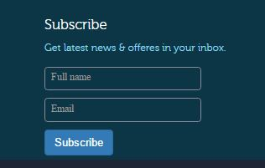

**V) To send an email to the company:**

1. Scroll down to the contact us form or click the contact us item from the navbar.
2. Fill out the information and click send



**Admin:**

**To add a new blog post:**

1. Click Add New post button from the blog page

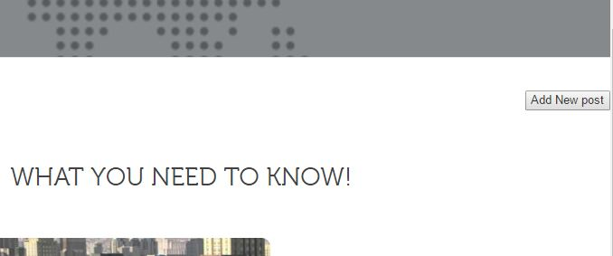

2. Login using following credentials

Username: admin

Password: [Provided to the instructor]



3. Then you will be redirected to the new blog post form. Fill out the new blog post and click submit.

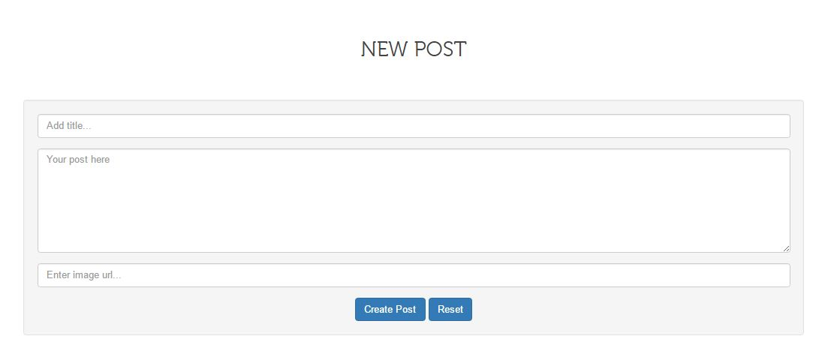

## Installation/Maintenance

1. Install mongodb from <https://www.mongodb.com/download-center?jmp=nav#community>
2. Install nodejs from <https://nodejs.org/en/>
3. Install visual studio from https://code.visualstudio.com/
4. Download the Swifast <https://github.com/FIU-SCIS-Senior-Projects/Swifast-Website-1.0> and save to a desired location.
5. Open visual studio code and open the Swifast project
6. Open the terminal either in visual studio code or cmd
7. Open the project folder in the command line
8. Inside the code folder type npm install on the command line.
9. Open api folder which is inside the code folder in the terminal
10. Type npm install
11. Inside the api folder (inside the code folder) type npm start
12. Open another terminal and from the code folder type nodemon to start the server

Note: If the nodemon command is not working you have to install it first by typing npm install -g nodemon inside the Code folder

1. Open the browser and type <http://localhost:4000>

**Accessing the mlab (cloud database):**

1. Go to <https://mlab.com/>
2. Login using the following credentials:

Username: [provided to the instructor]

Password: [provided to the instructor]

## Shortcomings/Wishlist

Some the feature that we wished to complete are:

* Provide the admin a delete button to delete a blog post
* Shows the logout button only if the admin is logged in.
* Provide read more button to the blog articles
* Allow to upload the image from computer when posting new article.

# References

1. Code, Visual Studio. *Visual Studio Code*. 05 04 2017. 14 02 2017. <https://code.visualstudio.com/docs/nodejs/nodejs-tutorial>.
2. Codevolution. *YouTube*. 22 05 2016. 01 03 2017. <https://www.youtube.com/watch?v=zj7_4VDFQPA&list=PLC3y8-rFHvwg5gEu2KF4sbGvpUqMRSBSW >.
3. Media, Traversy. *Youtube*. 1 10 2016. 23 01 2017. < https://www.youtube.com/watch?v=PFP0oXNNveg>.
4. Schemittling, Selene. *YouTube*. 24 01 2016. 10 02 2017. <https://www.youtube.com/watch?v=6cLlX0ZqO5Q>.
5. Sevilleja, Chris. *Scotch*. 24 01 2014. 12 02 2017. <https://scotch.io/tutorials/setting-up-a-mean-stack-single-page-application>.